Audiences’ Motives for Watching Live Video Streaming

Chih-Chien Wang
Graduate Institute of Information Management, National Taipei University
E-mail: wangson@mail.ntpu.edu.tw

Feng-Sha Chou
Department of Business Administration, National Taipei University
E-mail: choufengsha@gmail.com

ABSTRACT
Due to the popularity and low cost of rapid mobile internet connection, live-streaming service is now booming. Some of these users who provide live video shows to the public are famous and known as vloggers or YouTube celebrities. The content of the live show is diverse. Some YouTubers broadcast video of their computer screen when playing an online game; others cook, work out, or put on makeup on camera. Nearly anything from one’s daily life is fair game. The abundant live video streaming content attracts youngsters as well as adults. To understand the viewers’ motivation for watching live video streaming, this study used a self-reporting online questionnaire survey. A total of 374 responses were received and analyzed to ascertain the motives of viewing live video streaming. Based on the empirical survey results, we propose a motivation of YouTuber model composed of four motive categories: leisure, celebrity worship, social connection, and voyeurism. These four categories can be divided into eight motives, including passing time, entertainment, relaxation, celebrity identification, vicarious participation, companionship, social interaction, and voyeurism.

Keywords: Live video stream, Web live show, YouTuber, Vlogger, Internet celebrity

INTRODUCTION
Live video is “one of the things I’m most excited about,” address by Facebook CEO Mark Zuckerberg in 2016. Facebook has offered a live video feature since 2016 (Guynn, 2016). For social media, live video or live streaming is now an essential feature that allows people to broadcast live video to friends (and to the public at large). As Zuckerberg predicted, video will be the primary method for users to share content in the future. The live streaming feature of social media has become more and more important since its inception. It is no longer limited to social media: there are also apps that focus on providing live streaming services for users. The live streaming industry market is now booming, and live streaming itself has become a new social media with a high impact (Liu, 2016). Hundreds of live video social apps have emerged during the past few years. According to search results in Google Android Market with a keyword of “live streaming video”, there are 237 apps with the function of “live streaming video” (searched on July 4, 2017). Live streaming video is now an emerging market opportunity that attracts industry practices.
Streaming media constantly delivers video (or audio) from a provider to receivers (https://en.wikipedia.org/ wiki/Streaming_media). Unlike downloading, which is a process that allows audiences to obtain the entire video or audio before watching or listening, streaming refers to the delivery method, i.e., the process of constant delivery of video or audio. The delivered content can be “live” only when the delivery speed is fast enough to avoid significant lag.
Live video streaming service is booming with an increasing user base. With live video streaming services, users can broadcast their activities to others in real time. Live video streaming services are usually synchronous, and users broadcast their activities while the audience views the video and responds at the same time (Scheibe, Fietkiewicz, & Stock, 2016). It is feasible and available due to the advance in mobile devices, including high-resolution display screens, a high-speed process for visual content, high-quality cameras, and a high penetration rate of high-speed mobile communication. The technique requirement is easy to reach when a user wants to serve as a broadcaster (live video content provider) or just as an audience (live video content viewer).
Some broadcasters become famous, attracting millions of viewers. The content of the live video streaming is diverse. Some broadcasters circulate their computer screen when playing online games; others cook, work out, or put on makeup on camera. Nearly anything from one’s daily life is fair game. The abundant contents of live video streaming attract youngsters as well as adults. They spent much time on live video streaming.
With live video streaming, people now can broadcast their own lives to share their daily activities in real time, as predicted by the 1998 film The Truman Show. By viewing live video streaming, audiences are privy to broadcasters’ personal activities and private affairs. Live video streaming attracts audiences’ attention, and some audiences spend significant time on viewing the live streaming video.
However, little previous research focuses on exploring the participation behavior of live video streaming audiences (Hu, Zhang, & Wang, 2017). The current study focuses on understanding the motivations for audiences to view live video streaming.

Table 1. Estimated Social Network Sites Users in Taiwan
 |  | (A.)  Taiwan Population (age 13 and above) | (B.)  Internet Usage Penetration (%) | (C.)  SNS Penetration (% of Internet User) | (A) x (B) x (C) Estimated SNS population in Taiwan | Estimated Percentage of SNS users | Actual Respondent of the study (% of samples)
13-19 | male | 1,109,856 | 97.89% | 80.12% | 870,454 | 6.4% | 8.3%
 | female | 1,017,152 | 97.89% | 80.12% | 797,747 | 5.9% | 9.1%
20-29 | male | 1,664,421 | 98.08% | 92.49% | 1,509,866 | 11.2% | 7.5%
 | female | 1,545,765 | 98.08% | 92.49% | 1,402,228 | 10.4% | 17.6%
30-39 | male | 1,896,047 | 97.23% | 86.51% | 1,594,835 | 11.8% | 12.8%
 | female | 1,914,692 | 97.23% | 86.51% | 1,610,518 | 11.9% | 15.8%
40-49 | male | 1,804,613 | 92.66% | 76.55% | 1,280,034 | 9.5% | 7.5%
 | female | 1,849,137 | 92.66% | 76.55% | 1,311,616 | 9.7% | 8.0%
50-59 | male | 1,785,760 | 80.79% | 63.35% | 913,960 | 6.8% | 3.7%
 | female | 1,842,545 | 80.79% | 63.35% | 943,023 | 7.0% | 5.9%
60 and  above | male | 1,432,398 | 62.70% | 53.10% | 476,898 | 3.5% | 1.9%
 | female | 2,475,136 | 62.70% | 53.10% | 824,064 | 6.1% | 1.9%

METHOD

Participants
This study used a self-reporting online questionnaire survey to collect data. The participants were viewers of live video streaming. We posted advertisements for volunteers on Facebook to recruit Taiwanese participants, since Facebook is the largest social media site in Taiwan, with a more than ninety percent penetration rate. Because age may be an influential factor for viewing behavior of reality television programs (Ebersole & Woods, 2007), the study used stratified sampling to make sure the samples were representative of the whole population of Taiwanese internet users. The stratified sampling of the study was based on the research report of “2016 Summary Report: Wireless Internet Usage in Taiwan” (Taiwan Network Information Center [TWNIC], 2016), which presented the penetration of Taiwanese usage of Internet and social networking sites (SNS). The “Household registration statistics data” by Taiwan Ministry of the Interior was also used to determine the sample numbers for stratified sampling. This study calculated the age percentage distribution of social media users, shown in Table 1. We used this distribution to allocate budget for Facebook ads to recruit participants.

Procedure
We employed an online questionnaire for a period of 2 weeks. Participants in this study were voluntarily and the questionnaire took approximately 10 min to finish. The questionnaire consisted of two parts. First, we asked participants to report their internet live show viewing behavior and their demographic data. Second, the participants answered questions about the motives of viewing an Internet live show. All volunteers through Facebook Ads to access the online questionnaire. We offered a lottery to participants who completed the online questionnaire. The prize was twenty NT100 (about USD 3.30) convenience store gift certificates.

Measurement
Based on the literature review for the potential motivations for viewing live streaming, nine motivations were included in this study, including passing time, entertainment, relaxation, celebrity identification, vicarious participation, companionship, social interaction, and voyeurism. We selected two items for each motivation. A five-point Likert-type scale, ranging from 1 (Strongly Disagree) to 5 (Strongly Agree), was used to measure these nine motivations.
The measurement scale for motivations of passing time, entertainment, relaxation, companionship, and social interaction was adopted from [6]. Vicarious participation was measured by asking participants how they felt about “Dreaming about live streaming myself” and “Pretending that I’m a contestant on a live stream”, which was developed by Papacharissi & Mendelson (2007). Two item measurement scales for identification to broadcasters were adopted from Um (2013). Three items modified from Baruh (2010) were used to measure voyeurism. We asked participants to answer three questions as below, “I enjoy watching live Internet shows that give me a glimpse into broadcasters’ private moments.” “I like live Internet shows that reveal a side of broadcasters that I would not normally see.” “I enjoy watching live Internet shows that provide access to things that broadcasters try to hide.”

Table 2. Demographic profile of participants
Measure | items | percentage
Gender | Male | 41.7%
 | Female | 58.3%
Age | Below 20 years | 17.4%
 | 21-30 | 25.1%
 | 31-40 | 28.6%
 | 41-50 | 15.5%
 | Above 51 | 13.4%
Career | Student | 26.1%
 | Employed | 50.4%
 | Between jobs | 15.1%
 | Retirement | 8.5%
Frequency for watching internet live video show | Always | 10.7%
 | Once a day | 11.8%
 | Once 2-3days | 23.3%
 | Once a week | 17.4%
 | Seldom | 12.6%
 | Never | 24.3%

RESULTS

Demographic
This study recruited 374 participants to join. 58.3% of the participants were female (n=218), and the other 41.7% were male (n=156). 53.7% of the participants were between 20 and 40 years old. Most participants were employed (50.4%). Overall, 75.8% of participants had experience viewing live internet video shows. Table 2 shows the descriptive statistics of the respondents’ demographic profiles, including gender, job career, age, and frequency of watching live internet video shows.

Scale Reliability and Validity
To verify the construct reliability, we computed Cronbach’s alpha and composite reliabilities (CR) to evaluate the internal consistency among items to each construct of this study. The Cronbach’s alpha value of all constructs in our model exceeds the usual .70 benchmark (Hair, Black, Babin, Anderson, & Tatham, 2016). The Cronbach’s alpha value of each construct ranged from 0.674 to 0.901. This study calculated composite reliabilities for each construct. The value of composite reliabilities of each construct ranged from 0.803 to 0.940. The results demonstrated each construct to be satisfactory, with all coefficients greater than the recommended threshold of 0.70, following the suggestion of (Nunnally, 1967). The coefficients of Cronbach’s alpha and CR demonstrated that the constructs were within acceptable reliability.

Table 3. Scale reliabilities and Validity
Motivations | Items | Cronbach’s α | Composite Reliability (CR) | Average Variance Extracted  (AVE)
Pass Time | 2 | 0.848 | 0.861 | 0.755
Entertainment | 2 | 0.818 | 0.838 | 0.721
Relaxation | 2 | 0.856 | 0.867 | 0.765
Celebrity Identification | 2 | 0.788 | 0.803 | 0.671
Vicarious Participation | 2 | 0.817 | 0.837 | 0.718
Companionship | 2 | 0.875 | 0.873 | 0.775
Social interaction | 2 | 0.817 | 0.827 | 0.705
Voyeurism | 3 | 0.935 | 0.940 | 0.839

We accessed the convergent validity of scales by calculating the standardized factor loading and Average Variance Extracted (AVE) of each construct of Confirmatory Factor Analysis (CFA) model. The standardized factor loading for each item ranged from 0.78 to 0.96 and had a significant loading with the appropriate latent construct, thereby demonstrating adequate convergent validity. The AVE value of all constructs were the above criteria of 0.50 (ranging from 0.671 to 0.839) (Fornell & Larcker, 1981), which indicated adequate convergent validity. The results are listed in Table 3.
Table 4 demonstrates correlations among the latent constructs and the root of AVE in the diagonal of the matrix. On the suggestion of Fornell and Larcker (1981), we accessed the discriminant validity of the latent constructs in terms of the root of AVE. Comparing of the root of AVE with corresponding correlation estimate of any two constructs, if the root of the AVEs are greater than the correlation between the constructs, the requirements for discriminant validity are satisfied. However, the result indicated that all but two factors (entertainment and relaxation) had adequate discriminant validity. The root of the AVEs for entertainment motivation was 0.849, which was slightly lower than the correlation coefficient between relaxation and entertainment (0.892). The root of the AVEs for relaxation motivation was 0.875, which was slightly lower than the correlation coefficient between relaxation and entertainment (0.892). The remaining six factors were with acceptable discriminant validity.

Exploratory Factor Analysis
This study proposes eight motivations to explain why audiences watch live video streams. However, according to Table 4, there is a significant correlation among these eight motivations. To check if these eight factors can be further classified into several categories, we employed the exploratory factor analysis (EFA) to extract second-order factors to confirm whether the eight factors could be concentrated into fewer dimensions. As Table 5 indicates, the eight factors could be condensed into four motivation categories. This study named these motivation categories of watching video live streaming as leisure, celebrity worship, social connection, and voyeurism.

Table 4. Correlation Coefficient and Discriminant Validity of the Measurement Model
 | CI | VP | VO | PT | EN | RE | CO | SI
CI | 0.819
VP | 0.779*** | 0.847
VO | 0.571*** | 0.621*** | 0.916
PT | 0.605*** | 0.672*** | 0.700*** | 0.869
EN | 0.595*** | 0.622*** | 0.724*** | 0.816*** | 0.849
RE | 0.655*** | 0.706*** | 0.713*** | 0.866*** | 0.892*** | 0.875
CO | 0.660*** | 0.745*** | 0.697*** | 0.752*** | 0.732*** | 0.816*** | 0.880
SI | 0.680*** | 0.732*** | 0.680*** | 0.753*** | 0.713*** | 0.800*** | 0.788*** | 0.840
- CI=Celebrity Identification, VP= Vicarious Participation, VO= Voyeurism, PT= Pass Time, EN= Entertainment, RE= Relaxation, CO= Companionship, SI= Social interaction
- The diagonal reveals values of the root of the average variance extracted (AVE) for each variable

Table 5. The exploratory Factor Analysis Results of the Motivation of Watching a Live Video Stream
Dimensions | Sub-dimension | Leisure | Celebrity Worship | Social Connection | Voyeurism
Leisure | Pass Time | 0.779 | 0.328 | 0.347 | 0.231
 | Entertainment | 0.813 | 0.254 | 0.254 | 0.363
 | Relaxation | 0.777 | 0.321 | 0.406 | 0.258
Celebrity Worship | Celebrity identification | 0.320 | 0.870 | 0.228 | 0.223
 | Vicarious participation | 0.290 | 0.695 | 0.533 | 0.222
Social Connection | Companionship | 0.427 | 0.341 | 0.704 | 0.333
 | Social interaction | 0.488 | 0.366 | 0.666 | 0.218
Voyeurism | Voyeurism | 0.401 | 0.282 | 0.281 | 0.820

Leisure motivation included three factors: Passing time, entertainment, and relaxation. Celebrity worship motivation covered celebrity identification and vicarious participation. Social connection motivation contained companionship and social interaction factors. Voyeurism motivation included only voyeurism, as shown in Figure 1.

Figure 1. The Motivation Dimensions of Watching a Live Video Stream

The leisure motivation reveals that audiences take a break, have fun, and relieve stress by viewing live video streaming. Celebrity worship indicated that audience identifies with their favorite broadcaster and learns what is real and close to them by viewing their video stream. This parasocial interaction gives the audience satisfaction. The social connection motivation means the audience uses the contents of live video streaming to interact with their friends, family, and others, which will decrease the level of companionship. Finally, the subjects of video live streaming usually want to approach star’s real life. The audience may be curious about everything of their favorite star(s), which drives them to view the video streaming to fulfill their desire.

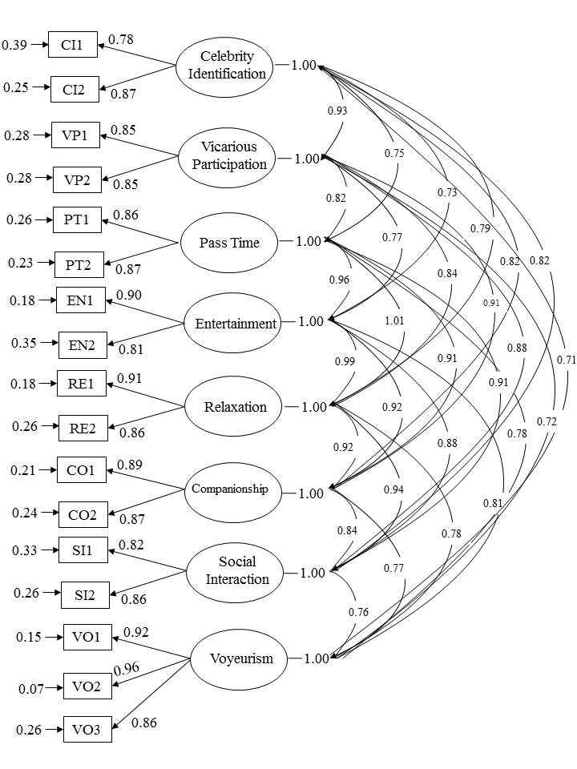
Chi-Square=641.97, df=91, p<0.001, RMSEA=0.133, GFI=0.82, AGFI=0.70, SRMR=0.034, RMR=0.034, NFI=0.91, NNFI=0.89, CFI=0.92
Figure 2. The Results of CFA of the First-Order Model

To confirm whether the second-order dimension of the motivation model of watching live video stream is appropriate, we conducted two confirmatory factor analyses (CFA). The first CFA included eight one-order factors and the other included second-order factors CFA, shown as Figures 2 and 3. This study used the chi-square ratio to test the goodness-of-fit. On the suggestion of Hayduk (1987), we compare with the chi-square ratio of the first-order model and second-order model. The ratio of χ2 and df (degree of freedom) of the first-order model was 7.05, and the ratio of χ2 and df (degree of freedom) of the second-order model was 3.99, which nearly the threshold value of 3. Thus, the later one (the second-order model) has a better goodness-of-fit.
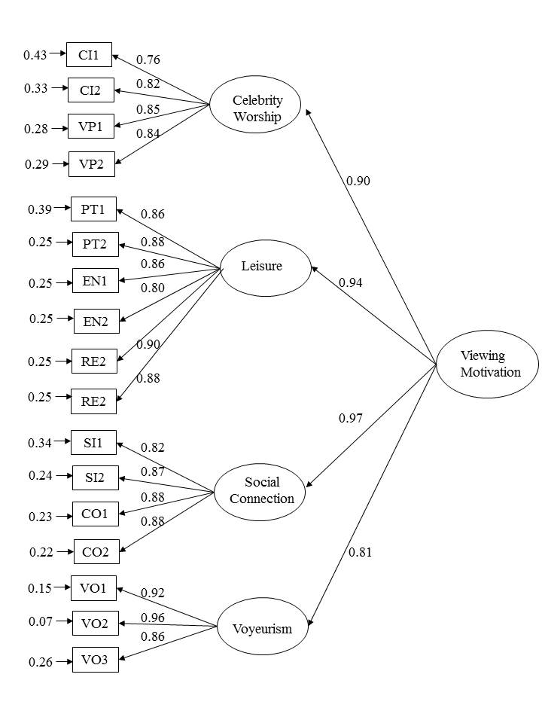
Chi-Square=438.93, df=110, p<0.001, RMSEA=0.094, GFI=0.87, AGFI=0.82, SRMR=0.037, RMR=0.037, NFI=0.93, NNFI=0.93, CFI=0.95
Figure 3. The Results of CFA of Second-Order Model

In otherwise, the model fit indictors of first-order model is RMSEA=0.133, GFI=0.82, AGFI=0.70, SRMR=0.034, RMR=0.034, NFI=0.91, NNFI=0.89, CFI=0.92, and the model fit indictors of second-order model is RMSEA=0.094, GFI=0.87, AGFI=0.82, SRMR=0.037, RMR=0.037, NFI=0.93, NNFI=0.93, CFI=0.95. The model fit indictors of second-order model is better than the first-order model; that is, the second-order model is able to explain the motivation for viewing live video stream.

DISCUSSION
Live video streaming is an emerging internet application that attracts sights from audiences, academics, and industry practices. Many audiences spend significant time viewing live streaming. However, few previous studies have focused on exploring the motivations why audiences keep viewing live video streaming. The current study reveals four motivations for view live streaming: leisure, celebrity worship, social connection, and voyeurism. The motivation of leisure can be further divided into three sub-motivations of passing time, entertainment, relaxation. The motivation of celebrity worship can be further divided into two sub-motivations of celebrity identification and vicarious participation. The motivation of social connection can be further divided into two sub-motivations of companionship and social interaction. Additionally, the study reveals that voyeurism is the fourth dimension for viewing live video streaming. Although most studies focus on the adoption issue of online behavior, the literature also discussed addiction issues (reference). This study discusses the motivation of live stream behavior. Nevertheless, addiction is also an important issue for live stream behavior. Future studies may discuss the factors influencing live stream addiction. Some motives of live stream behavior may also factor for live stream addiction (Islam, Karia, Khaleel, Khalid, Al Mamun, Bhuiyan, & Fouji, 2019). Furthermore, investigating audiences' motivations can help the industry understand their preferences. Understanding what live streamers have provided can help understand the current market status. The literature up to now has focused on analyzing social commerce content to understand post quantity and content types in customer engagement on Facebook pages (reference). Future studies may also investigate the content provided by live streamers. Comparing the motivations of live stream audience and content provided by live streamers can help to realize the gap between demand and supply of the live stream industry (Thongmak, 2019).

REFERENCE
Baruh, L. (2010). Mediated voyeurism and the guilty pleasure of consuming reality television. Media Psychology, 13(3), 201-221, 2010.
https://doi.org/10.1080/15213269.2010.502871
Ebersole, S., & Woods, R. (2007). Motivations for viewing reality television: A uses and gratifications analysis. Southwestern Mass Communication Journal, 23(1), 23-42.
Fornell, C., & Larcker, D. F. (1981). Structural equation models with unobservable variables and measurement error: Algebra and statistics. Journal of Marketing Research, 18(3), 382-388. https://doi.org/10.1177/002224378101800313
Guynn, J. (2016). Mark Zuckerberg embraces live video. Retrieved from https://www.usatoday.com/story/tech/news/2016/02/26/mark-zuckerberg-facebook-live-video/80992540/
Hair, J. F., Black, W. C., Babin, B. J., Anderson, R. E., & Tatham, R. L. (2016). Multivariate data analysis (6th ed). Upper Saddle River, NJ: Pearson Prentice Hall.
Hayduk, L. A. (1987). Structural equation modeling with LISREL: Essentials and advances. Jhu Press.
Hu, M., Zhang, M., & Wang, Y. (2017). Why do audiences choose to keep watching on live video streaming platforms? An explanation of dual identification framework. Computers in Human Behavior, 75, 594-606.
https://doi.org/10.1016/j.chb.2017.06.006
Islam, M. S., Karia, N., Khaleel, M., Khalid, J., Al Mamun, M. A., Bhuiyan, M. Y. A., & Fouji, M. H. (2019). From ICT adoption to ICT addiction: What really matters between the use of ICT and learning performance?. International Journal of Electronic Commerce Studies, 9(2), 133-159.
Liu, X. (2016). Live streaming in China: Boom market, business model and risk regulation. Journal of Residuals Science & Technology, 13(8), 284.1-284.7. Retrieved from http://www.destechpub.net/2019/JRST-Volume-13-Number-8-2016.pdf.
Nunnally, J. C., & Bernstein, I. H. (1967). Psychometric Theory. 3rd Edition, McGraw-Hill, New York.
Papacharissi, Z., & Mendelson, A. L. (2007). An exploratory study of reality appeal: Uses and gratifications of reality TV shows. Journal of Broadcasting & Electronic Media, 51(2), 355-370. https://doi.org/10.1080/08838150701307152
Rudin, S., Niccol, A., Feldman, E. S., & Schroeder, A. (Producer), & Weir, P. (Director). (1998). The Truman show [science fiction comedy-drama]. Hollywood: Paramount pictures.
Scheibe, K., Fietkiewicz, K. J., & Stock, W. G. (2016). Information behavior on social live streaming services. Journal of Information Science Theory and Practice, 4(2), 6-20. https://doi.org/10.1633/jistap.2016.4.2.1
Taiwan Network Information Center [TWNIC]. (2016). 2016 summary report: Wireless internet usage in Taiwan.
Thongmak, M. (2019). Do we know what contents work for social commerce? A case of customer engagement in Facebook brand pages. International Journal of Electronic Commerce Studies, 10(2), 141-174.
http://dx.doi.org/10.7903/ijecs.1602
Um, N. H. (2013). Celebrity scandal fallout: How attribution style can protect the sponsor. Psychology & Marketing, 30(6), 529-541.
https://doi.org/10.1002/mar.20625

Pro. Chih-Chien Wang is currently a professor in the Graduate Institute of Information Management, National Taipei University. He has authored and co-authored several textbooks and one hundred journal and conference papers. His research interests are in the areas of fake news, anti-spammer, electronic commerce, internet marketing, cyber society, and online behavior.

Feng-Sha Chou (Corresponding author) is currently a Ph.D. student in the Department of Business Administration, National Taipei University. Her research interests are in the areas of electronic commerce, consumer behavioral, and new product marketing.

