The Rising and Fall of Mobile Phone Enterprises:
Patent-Based Competitive Advantage Analysis

Yann-Jy Yang
Center for General Education, National Central University, Taiwan
yjyang@ncu.edu.tw

ABSTRACT
The mobile phone has been one of the most critical technological innovations in the last three decades. However, the pioneer and legendary mobile phone giants no longer hold their competitive advantage. Nowadays, many major mobile phone manufacturers are just newcomers of the past ten or fifteen years. The development of the mobile phone industry is a massive example of revealing the sustainability of competitive advantage and exploring the role of the patented invention in the competitive position of technology products. The current study analyses the rise and fall of mobile phone companies from the perspective of patent analysis. We summarize the key market shareholders of mobile phones and search the patent database to obtain the number of patented inventions of these mobile phone companies. The study analyses the yearly trend of patented inventions in different technology fields. By correspondence analysis, the study figures out the technological competitive advantage of these mobile phone companies in different periods. We aim to explore the rise and fall of mobile phone companies from the perspective of patented innovation and to realize the role of technology advantage as the root of competitiveness in the mobile phone industry. The influences of the Chip War against China and the Chips Act of the US Federate Government are also discussed.

Keywords: Patent analysis, Mobile phone, Competition, Competitive advantage, Correspondence analysis

INTRODUCTION
Mobile phones, one of the most critical technological innovations in the last three decades, have changed people’s lives. Initially, the mobile phone was a portable telephone that people could use to communicate with others anytime and anywhere. With a mobile phone, people need to stay away from home or the office to wait for incoming phone calls. However, the current mobile phone is not just a phone; it is a portable computing device that can do almost anything a personal computer can do. It is a powerful network-connected computer with enormous functions. The smart mobile phone is now not only a phone but also a computer, communication equipment, an entertainment device, a productivity tool, and a personal assistant. It already becomes a necessity for the daily lives of most people.
Mobile phones also play a significant role in economic development in the past few years. It contributes to a significant part of the economic development of many countries. It is with sale revenue and is still in the growth stage of the product life cycle. The price of some high-end mobile phones is higher than that of personal computers. The sale volume is still at a high level. Even though the penetration rate of mobile phones is close to one hundred percent, most people replace their mobile regularly to enjoy the new feature of the newly launched model. Even people who do not upgrade their mobile phone still need a new one when the old one is out-of-order or the telecommunication system upgrades (such as from GSM upgraded to 3G, 3G upgraded to 4G LTE, 4G LTE upgraded to 5G, and in the future from 5G upgrade to 6G). These factors contribute to the high market sale of mobile phones.
The mobile phone industry can be considered an oligopoly market field (Kaimann & Hoyer, 2019). However, no mobile phone dominated the market from the beginning. Some mobile phone pioneers in the 1990s and early 2000s, such as Nokia, Motorola, Siemens, and Ericsson, are no longer key players in the current mobile phone industry. From the beginning, some pioneer and legendary mobile phone giants had already lost their competitive advantage. Nowadays, some major mobile phone manufacturers are just newcomers of the past ten or fifteen years. Some challengers, such as Blackberry, experienced their whole product life cycle of introduction, growth, maturity, saturation, and decline in just a few years. These mobile phone companies entered the market, won the market share, and then lost it. All of these happen in just a matter of years.
Nevertheless, some competitors, such as Apple iPhone, survive and become market dominators. They earn market share through advanced technology and innovative design and become a dominant player in the market. Apple Inc., for example, is now a dominant player in the market, and its iPhone is in first or second place of top sale mobile phones. However, Apple Inc. was also a late-mover that entered the mobile phone market as late as 2007.
The dynamic competition (Clark & Nilssen, 2020; Rosar & Mueller, 2015) among mobile phone companies is an interesting strategy and technology management issue. The rise and fall of mobile phone companies can be attributed to various factors. Superior technological capability is one potential explanation. The mobile phone is a technological innovation, and many consumers prefer an innovative mobile phone with advanced and superior features. Companies with technology competence can launch new mobile phone products that attract sight from consumers.
The dynamic development of the mobile phone industry is an amazing example to reveal the sustainability of technology advantage and explore the role of patented invention in the competitive position of technology products. The patent is a key weapon to protect the invention (Webber, 2003) and keep them away from competitors’ imitation for a period (twenty years in most countries). Patent owners can hold sustainable technology advantages from granted patents. However, patents need to protect the invention to ensure the technological advantage of the invention is sustainable since competitors can easily imitate it if they know the hidden secret behind the invention. Analyzing the granted patent can help realize firms’ sustainable technology advantage.
Patent data analysis is considered an important competitor analysis approach (Ernst, 2003). Previous studies have used patent analysis to explore the competitive advantage of firms in the industry (i.e., Blind et al., 2022; Pantano et al., 2017; Shih et al., 2010; Trautrims et al., 2017; Yang et al., 2018). This study analyzes the granted patent to discuss the association between technology capability and competitive advantage. We argue that the mobile phone pioneers lost their market share because they lost their leading position in technology innovation. Technology advantage plays an important role in the competition of high technology products like mobile phones. We also argue that mobile phone companies have to keep the trend of technological change since the focus on technology competence is changing over time. Newcomers of mobile phone models attract consumers because of the new features enabled by new technology.

LITERATURE REVIEW

Evolution of the Mobile Phone
The first historical handheld mobile phone was invented in 1973. However, the first-generation mobile phone was with analog transmission rather than digital transmission. The rapid development of mobile phones started in the 1990s when second-generation mobile phone telecommunication systems (GSM in Europe and CDMA in the US) were commercialized. The followings are brief statements about the evolution of mobile phones. The evolution of the mobile phone is summarized in table 1.
Table 1 The Evolution of Mobile Phone
Years | Stage | Major event | Major mobile phone companies
1990-1994 | Infancy stage | 2G digital transmission mobile phone launched.  The commercial launch of a digital mobile phone. | NEC, Motorola, Nokia
1995-1999 | Introduction stage | Most countries began their mobile phone infrastructure construction.  Worldwide people have begun to use the mobile phone | Alcatel, Ericsson, Motorola, Nokia, Panasonic, Samsung
2000-2004 | Smartphone stage | The appearance of smartphone such as Blackberry.  3G was commercially launched. | Sony Ericsson, LG, Motorola. Nokia, Samsung, Siemens
2005-2009 | Powerful Smartphone stage | Multiple functions were integrated into mobile phones, including taking photos, playing music, email communication, web surfing, text messages, etc.  Apple iPhone commercial launched.  Android operating systems launched. | Apple Inc., Sony Ericsson, LG, Motorola. Nokia, Samsung, Siemens, Research in Motion (e.g., Blackberry)
2010-2014 | Mobile commerce Stage | Mobile phone companies, except Apple Inc., adopt the Google Android operating system to shorten their new product development cycle.  4G was commercially launched. | Apple Inc., Ericsson, HTC, Huawei, LG, Motorola. Nokia, Samsung, Research in Motion, Sony, ZTE
2015 and after | Intensive Competition Stage | Some newcomers from China became major mobile phone companies. There was Intensive hardware competition for these newcomers. | Apple Inc., Huawei, Lenovo, OPPO, Samsung, Xiaomin
2020 and after | Chip War | The US Government initialed the chip war against China. Huawei, Lenovo, OPPO, and Xiaomin are influenced by the Chips Act of 2022. | Apple Inc., Huawei, Lenovo, OPPO, Samsung, Xiaomin
Source: this research

1. 1990-1994: Infancy stage
In the early 1990s, the digital mobile phone was still in the infancy stage. Countries around the world began to construct their mobile phone telecommunication infrastructure. NEC, Nokia, and Motorola were the three dominant companies at this stage.

2. 1995-1999: Introduction stage
In the late 1990s, most countries began their mobile phone infrastructure construction. People around the world have begun to adopt mobile phones. The primary dominant companies were Alcatel, Ericsson, Motorola, Nokia, Panasonic, and Samsung.

3. 2000-2004: Smartphone stage
In the early 2000s, mobile phones began to be equipped with personal digital assistant features. In this period, most countries commercially launched 3G mobile telecommunication services. The mobile phone is not just a telephone. The Internet connection of mobile phones became feasible. Blackberry is the representative invention launched in this stage. Sony Ericsson, LG, Motorola. Nokia, Samsung, and Siemens are major mobile phone companies in the period.

4. 2005-2009: Powerful smartphone stage
In the late 2000s, the smartphone became a trend for mobile phones. From this period, the mobile phone is not just a phone; it is as powerful as a handheld computer. Multiple functions were integrated into mobile phones, including taking photos/recording video, playing music, email communication, web surfing, text messages, etc. In January 2007, Apple Inc. commercially launched iPhone. Also, in the late 2000s, the Android operating system launched. T-Mobile G1 (HTC Dream) was the first commercially available Android smartphone, announced in September 2008. The major mobile phone companies in this period were Apple Inc., Sony Ericsson, LG, and Motorola. Nokia, Samsung, Siemens, and Research in Motion (Blackberry). Blackberry was the hot sale mobile phone in the period, and iPhone became a shiny new product.

5. 2010-2014: Mobile commerce stage
In the early 2010s, mobile phone companies, except Apple Inc., adopt the Google Android operating system to shorten their new product development cycle. Most mobile phone companies no longer develop their operating systems. Instead, they adopt the Android operating system. For mobile phones with Android operating systems, there is only a tiny difference in operating systems, and companies had to focus on the hardware, peripherals, and appearance design of the mobile phones, such as touch screen, camera, fingerprint recognition, and much other hardware, firmware, and software features. During this period, many Chinese mobile phone companies enter the market. Besides, Apple Inc. (iPhone) and Samsung are two dominant mobile phone companies. Besides, Ericsson, HTC, Huawei, LG, Motorola, Nokia, Research in Motion, Sony, and ZTE were also major mobile phone companies in this period. 4G was a commercial launched in the period. Mobile commerce is feasible in this period.

6. 2015-2019: Intensive Competition Stage
During this period, some Chinese mobile phone companies became significant. They have a competitive advantage in price and compete with companies in design, hardware specifications, and software features. There was intense competition among these newcomers. iPhone and Samsung are still major dominant companies in the period. However, the market share of the China mobile phone companies, such as Huawei, Lenovo, OPPO, and Xiaomin, increased in this period.

7. 2020 and After Chip War
The “chip war” (Baek, 2022; Miller, 2022) against China was started by the US government. The Chips Act of 2022 has impacted some mobile phone manufacturers in China, including Huawei, Lenovo, OPPO, and Xiaomi, amongst others. The burgeoning technological development and the dramatically increasing number of patents held by Chinese mobile phone companies are two factors that have contributed to the chip wars.

METHODOLOGY

Data Collection and Analysis
A patent only protects the invention in the country that the patent is approved. The invention is not protected in countries where the patent applicant does not seek protection. Thus, most international mobile phone companies apply for patents in some major countries. Each invention may have multiple patent applications in different countries. The major mobile phone companies’ headquarters are settled in different countries in Europe, the United States, Canada, Japan, China, South Korea, and Taiwan. We may lose some patent records if we search for only one specific country’s patent database. If we search multiple patent databases, the patent numbers may be inflated, and duplicate patent records may exist.
Derwent world patents index ™ (DWPI) is a comprehensive patent database that collects worldwide patents from different countries and is frequently used in academic research (Souza et al., 2021; Wang & Li, 2021; Wang et al., 2011). In the DWPI database, all patents of the same invention of different countries are grouped into one patent record. Duplication of the patent records is not an issue in the DWPI database. Thus, we use the DWPI database rather than a specific country’s patent database.

Data periods
To analyze the rise and fall of mobile phone patents, we searched the Derwent World Patents Index to obtain the number of patented inventions of mobile phone companies in the period between 1990 to 2019. We divide the thirty years (1990-2019) into six periods, each with a period of five years, as illustrated in Table 1.

Searching keywords
Firstly, we use the term “mobile telephone”, “mobile device”, “cell phone”, “cell telephone”, “cellular phone”, and “cellular telephone” as keywords to search in the DWPI database.

Companies
In this study, we focus only on the mobile phone (handset), which is a consumer electronic product. The telecommunication infrastructure and network equipment market are totally different from the mobile phone market. The customers of telecommunication infrastructure and network equipment are telecommunication service providers, which are usually oligopoly companies in most countries. These telecommunication companies have to obtain concession and permission from the government, and in many cases, they have to pay concession fees for radio band frequency. Some of these telecommunication service providers are controlled or influenced by the government. Market competition and political power may influence the adoption of telecommunications infrastructure and network equipment. In this study, we first discuss the development trend of mobile phone patents. However, we only discussed the technological competition between mobile phone companies. This study does not discuss the technological competition between telecommunication infrastructures and network equipment companies.
Mobile phone companies usually belong to a large conglomerate with multiple companies and their subsidiaries (and even grandchildren or grand grandchildren subsidiaries). These business entities, including parent companies, subsidiaries, and subsidiaries of subsidiaries, operate under the control of one headquarters. Thus, we should consider the patents owned by the business conglomerate rather than one single company. However, it is not easy for academic researchers to figure out all companies owned by one large conglomerate since some company names are common terms used in many places. For example, apple is also a term for fruit and a common term used in our life. It is not always the case that businesses going by the name “Apple” are subsidiaries of Apple Computer. In the US state of California, you will find the town of Apple Village in San Bernardino County. There is a community known as Apple Grove in Mason County, West Virginia, in the United States. Companies located in Apple Village and Apple Grove are not related to Apple company. The patents are owned by Apple company when the company address is Cupertino, California, USA, and the company name is “Apple”, “Apple Inc”, or “Apple, Inc.”. It is not easy to just use company names to check if the mobile phone companies own the patents.
Besides, although some subsidy companies share a part of a conglomerate name in their company names, however, not all subsidy companies can be recognized by their company names. For example, S3 graphic (commonly referred to as S3) is merged with HTC after 2011 (https://en.wikipedia.org /wiki/S3_Graphics). Both S3 Graphic and S3 Inc. belong to HTC. Nevertheless, S3 Enterprises Inc. is a different company with no ownership relationship with HTC. It is not easy to use the company or conglomerate names to identify the real owner of the patent. If we just use the company names to search the database, we will make a mistake in judging the patent owned by the company.
The DWPI database manually checks companies’ ownership and tags the patent owner as a business conglomerate. DWPI assigned a unique assignee code for a major technology conglomerate (with more than 500 patents). All known subsidiaries, as well as the parent company, are included in the same code. The DWPI assignee code is useful in judging if the patents belong to mobile phone companies.
We do not search the original assignee field because it is difficult to identify and count the real owner of the patent. Instead, we use the assignee code to search the DWPI database. DWPI assigns a unique 4-letter code to approximately 21,000 companies worldwide. The codes can be used to retrieve subsidiaries and related holdings of the company group or conglomerate.

Fields
The study analyses the trend of the number of the patented invention of different technology fields using the DWPI manual code. DWPI manual codes are a hierarchical indexing system manually assigned by specialist teams. We used the first three codes to classify patents. In the current study, we do not choose International Patent Classification (IPC) by the World Intellectual Property Organization (WIPO) because IPC is assigned by reviewers of the intelligence property authority that grants the patent. Different reviewers from different countries may assign different IPC codes to the same patent. A reviewer team assigns DWPI manual codes of each patent according to the content and IPC codes of patents. Thus, DWPI manual code is more consistent than IPC code.
Most mobile phone patents concentrate on some classifications. To focus our discussion, we only select the top ten classification codes. In each period, these top ten codes contribute more than ninety percent of the granted patents of mobile phones.

Data analysis
The current study collects the patent data of mobile phones by major mobile phone companies and by years in the 30 years between 1990 to 2019. The patent numbers can be displayed as a contingency table with columns and rows of years and fields. The current study adopts correspondence analysis since it can provide a spatial representation to display the similarity of the rows and columns of a contingency table (correspondence table) by portraying row and column categories in the space of two or three dimensions (Calantone et al., 1989; Greenacre, 1984). The dimensions (axes) are the principal components identified in the correspondence analysis. The current study used correspondence analysis to process the data. In addition to correspondence analysis, we also plot the bar chart to illustrate the patent portfolio.

RESULT
1990-1994: Infancy stage
The progression of patent applications for mobile phones in the top ten fields from 1990 to 1999 is illustrated in Figure 1. All mobile phone patents were included in this figure, including those owned by major mobile phone companies, telecommunication infrastructure companies, network service provider companies, and others. Based on figure 1, we can find that in the early 1990s (infancy stage), the number of patents for mobile phones grew rapidly. In this period, most mobile phone patents belong to telephone and data transmission systems (W01) and broadcasting, radio, and line transmission systems (W02). The number of broadcasting, radio, and line transmission systems (W02) patents also rapidly increased. The early mobile phone is a combined product with features of the fix-line audio phone and digital radio communication. It is reasonable that in the beginning stage of the mobile phone life cycle, most companies focus on the research and development of telephone, data transmission systems, broadcasting, radio, and line transmission systems.

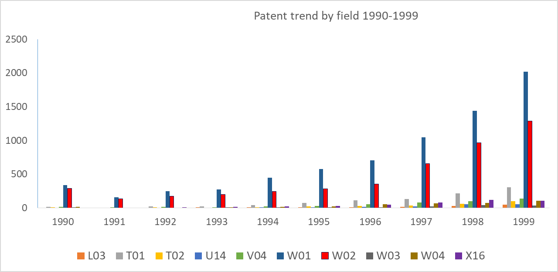
Figure 1 Patent trend by field in the Period of 1990-1999

However, in this stage, the mobile phone industry focuses more on telephone and data transmission systems (W01) than broadcasting, radio, and line transmission systems (W02). The increased speed of broadcasting, radio, and line transmission systems (W02) was lower than that of telephone and data transmission systems (W01).

Figure 2 patent portfolio in the period of 1990-1994
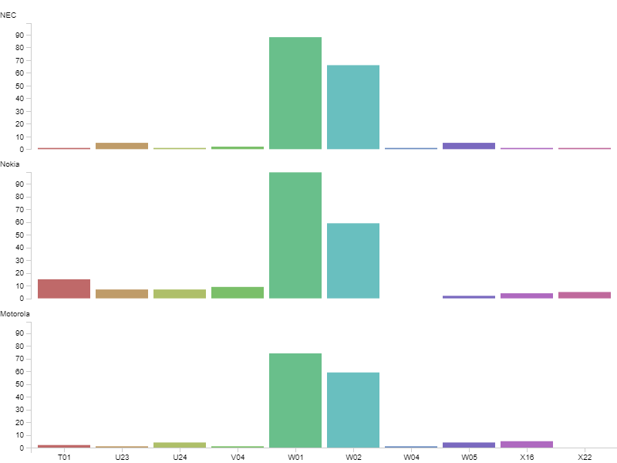
During the infancy stage, the dominant sub-technologies in the mobile phone field are transmission systems, especially for the telephone and data transmission systems (W01) and broadcasting, radio, and line transmission systems (W02). Nokia, NEC, and Motorola are the top three players in the number of mobile phone patents (figure 2).
The distance shown in the correspondence analysis figure reveals the focus of the company’s patent portfolio. The close distance means that the company focuses on the field, while the far distance means that the company has a lower proportion of patents in this field than other companies. The result of correspondence analysis for mobile phone patents in the period of 1990-1994 shows that Nokia, NEC, and Motorola all strived their effort on the telephone and data transmission systems (W01) since W01 is located close to the origin of the coordinates, (0, 0). Motorola and NEC were the similarity companies because the distance between the two companies was shorter than the distance to Nokia, shown in Figure 3. They had a similar patent portfolio, and both invested a higher proportion in the technology of broadcasting, radio, and line transmission systems (W02) than Nokia. According to figure 3, Nokia was close to W01, which revealed that Nokia had a larger proportion of patents in W01. On the other hand, Nokia dedicated not only to the transmission systems (W01 and W02) but also to other mobile phone technologies, such as digital computers (T01) and printed circuits and connectors (V04).

Figure 3 Correspondence analysis for mobile phone patents in the infancy stage
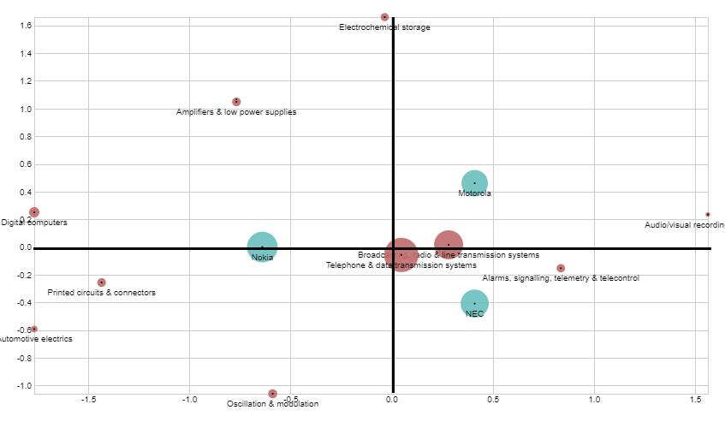
1995-1999: Introduction stage
In the late 1990s, the number of patents for mobile phones grew rapidly. In this period, most mobile phone patents belong to telephone and data transmission systems (W01) and broadcasting, radio, and line transmission systems (W02). Nevertheless, the increased rate of broadcasting, radio, and line transmission systems (W02) was lower than that of telephone and data transmission systems (W01). Besides, the proportion of digital computer (T01) patents dramatically increased. However, the total number of digital computer (T01) patents for mobile phones is still significantly lower than that of telephone and data transmission systems (W01) and broadcasting, radio and line transmission systems (W02).

Figure 4 Patent portfolio in the period of 1995-1999
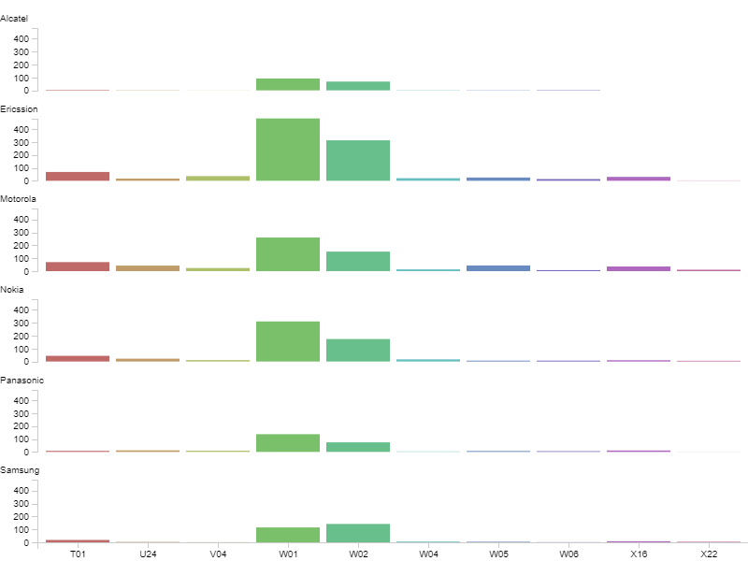
During this period, most mobile companies focus on transmission systems, including the telephone and data transmission systems (W01) and broadcasting, radio, and line transmission systems (W02), as shown in Figure 4. Digital computer technology (T01) was emerging and became third in the number of mobile phone patents. Alcatel, Ericsson, Motorola, Nokia, Panasonic, and Samsung were the six major players at this stage of the competition. The company Ericsson had 517 patents, which put it in the lead for the most patents held by any company. In terms of the number of patents, Nokia came in second with 331, followed by Motorola with 322. In this stage, Ericsson had a prominent competence in telephone and data transmission systems (W1), broadcasting, radio, and line transmission systems (W2). Ericsson was granted 482 and 313 patents in W01 and W02, more than Nokia’s 310 and 174 patents and more than Motorola’s 260 and 151 patents, respectively. However, Motorola is dedicated to digital computer technology (T01). The number of Motorola’s T01 patents was higher than that of Ericsson’s.
Figure 5 shows the result of correspondence analysis for mobile phone patents in 1995-1999. The telephone and data transmission systems (W01) and broadcasting, radio, and line transmission systems (W02) were still the focus. Ericsson and Nokia were very close to each other in the location, as shown in Figure 5. It means that Ericsson and Nokia had a similar patent portfolio. Chen (1996) argued that the competitive tension of paired companies would be high if they had similar resources. Thus, Ericsson and Nokia should be the direct competitors due to their similar patent portfolios. They both committed to developing telephone and data transmission systems (W01) and broadcasting, radio, and line transmission systems (W02), as shown in figure 5. Panasonic is another competitor of Ericsson and Nokia. However, Panasonic’s mobile phone patents (the size of circles in figure 5) were less than those of Ericsson and Nokia from 1995 to 1999.
The portfolio of Motorola was different from that of Ericsson, Nokia, and Panasonic. In Figure 5, we find that Motorola was closed to electrochemical storage (X16), digital computer (T01), and amplifiers and low power supplies (U24). In the other corner (upper right of Figure 5), Samsung was close to broadcasting, radio, and line transmission systems (W02) patents.

Figure 5 Correspondence analysis of mobile phone patents of 1995-1999
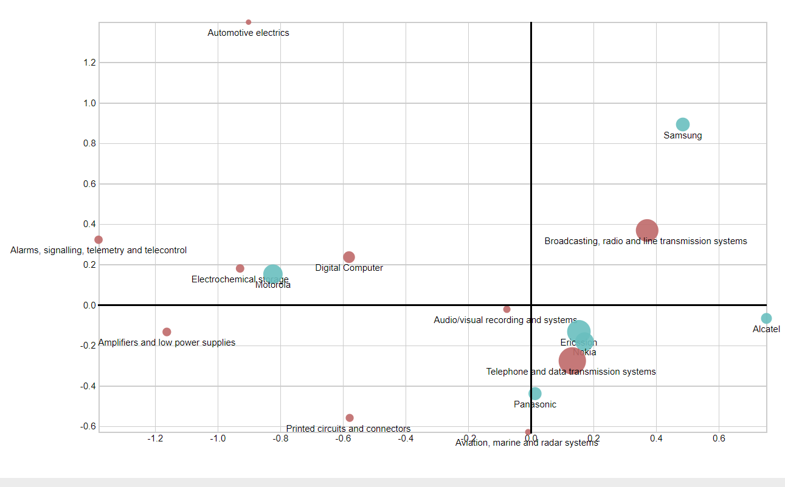
2000-2004: Smartphone stage
Figure 6 reveals the trend of mobile phone patents of the top ten fields by years in the period 2000 to 2009. All mobile phone patents were included in this figure, including the patents owned by or not by the major mobile phone companies. Based on Figure 6, we find that in the early 2000s, the number of patents on mobile phones grew rapidly. In this period, most mobile phone patents belonged to telephone and data transmission systems (W01) and digital computer (T01). The number of broadcasting, radio, and line transmission systems (W02) patents also rapidly increased. However, the increased speed of W02 patients was lower than that of W01 and T01. In this period, the mobile phone industry focused on telephone and data transmission systems (W01) and digital computer (T01). Although telephone and data transmission systems (W01) still contributed to the largest proportion of patents, the number of digital computer (T01) patents dramatically increased. The patent number of digital computer (T01) was more significant than that of broadcasting, radio, and line transmission systems (W02) from 2002.

Figure 6 Patent trend by field in the period of 2000-2009
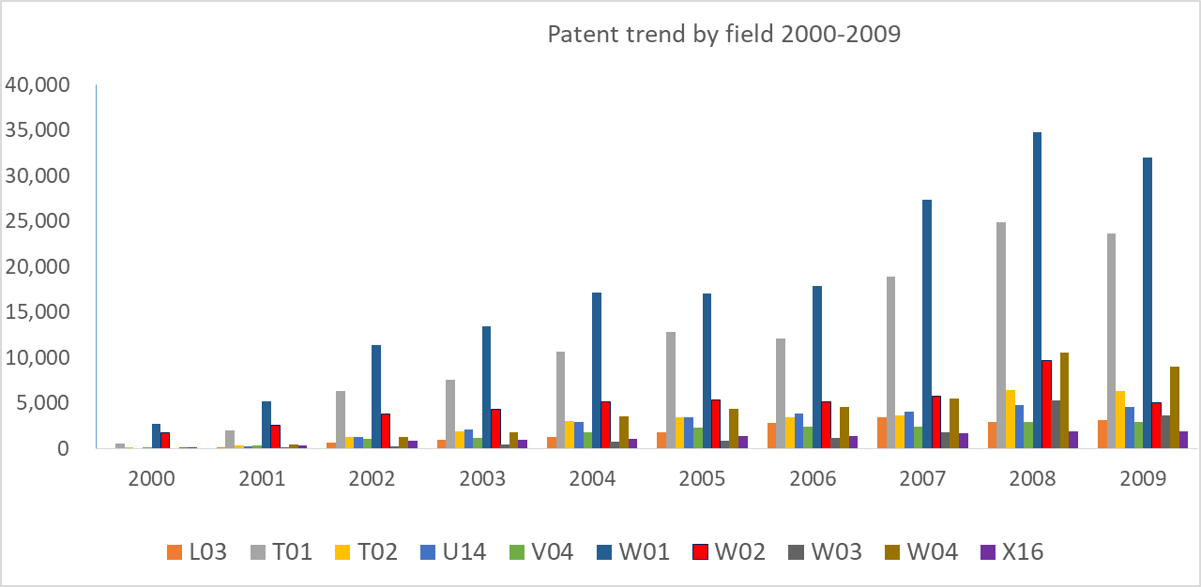
In the 2000s, the traditional voice-based mobile phone was equipped with a new personal assistant feature. During this stage, the technology of telephone and data transmission systems (W01) still contributes to the largest proportion of mobile phone patents. In figure 8, W01 is located close to the origin of the coordinates. However, unlike in the 1990s that the patent number of broadcasting, radio, and line transmission systems (W02) was in second place. Since 2002, the number of digital computer (T01) patents has risen to second place; the number of digital computer (T01) patents was more significant than that of broadcasting, radio and line transmission systems (W02) patents. Besides, audio/visual recording and systems (W04) patents also increase rapidly in this period, as shown in figure 6 and figure 7.
Sony-Ericsson and Nokia were in first and second place in the number of mobile phone patents during this period. Since mobile phone technology had diffused, there were more major mobile phone companies in this period than in the 1990s. Sony-Ericsson, Nokia LG, Motorola, Samsung, and Siemens dominated this period.
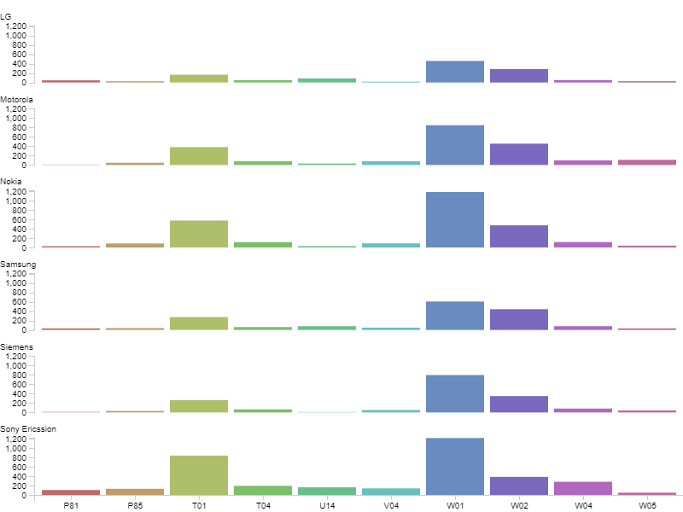
Figure 7 Patent portfolio in the period of 2000-2004
Figure 8 presents the findings of the correspondence analysis, which reveal a fierce level of competition among mobile phone players during this period. Motorola and Siemens competed with each other since their positions in figure 8 are quite close. It displays that they were with a similar technical portfolio, which can also be found in figure 7. The distance between Nokia and telephone and data systems was close, which reveals that Nokia still focused on the telephone and data transmission systems (W01) technology. Sony-Ericsson (joint brand of mobile phone Sony and Ericsson) hold the largest number of mobile phone patents in this period. Figure 8 also indicated that patents owned by Sony-Ericsson reached more broadly technical fields than other players in the period smartphone stage, including audio/visual recording and systems (W04), education, cryptography, adverts (P85), computer peripheral equipment (T04), digital computer (T01), and printed circuits and connectors (V04). The joint venture of Sony-Ericsson brought them technological competence.

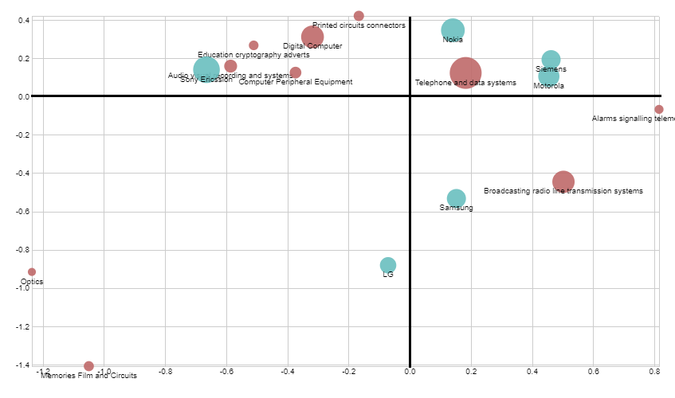
Figure 8 Correspondence analysis of mobile phone patents of 2000-2004

2005-2009: Powerful smartphone stage
In the late 2000s, the smartphone was more powerful than other mobile phone products. In this stage, the smartphone was internet-connected and with powerful features. Smartphones in this period could be used to send an email, surf websites, instant chat with other users, and do many other functions. At this stage, Blackberry was a powerful smartphone product. Apple launched the iPhone (using the iOS operating system), and the Android operating system was launched. iOS and Android both provide an open platform for third software providers to provide apps for mobile phones, which provide opportunities to enrich the applications of mobile phones.
In this period, the number of patents on mobile phones still overgrew. Telephone and data transmission systems (W01) and digital computer (T01) patents still contributed to a large proportion of patents. In this period, however, audio/visual recording and systems (W04) is a shiny field. The number of audio/visual recording and systems (W04) patents dramatically increase. The number of patents on analogue and hybrid computers (T02) also increased rapidly. The patent number of audio/visual recording and systems (W04) surpassed that of broadcasting, radio and line transmission systems (W02) since 2008. The patent number of analogue and hybrid computers (T02) was more than that of broadcasting, radio and line transmission systems (W02) since 2009. At the end of the 2000s, the first five places in the number of patents were telephone and data transmission systems (W01), digital computer (T01), audio/visual recording and systems (W04), analogue and hybrid computers (T02), and broadcasting, radio and line transmission systems (W02).
The late 2000s was a flourishing period for the mobile phone field. Many mobile phone companies entered the market, which induced intensive market competition. The major companies in this period included Apple Inc., Sony, LG, Motorola, Nokia, Samsung, Siemens, and BlackBerry.

Figure 9 Patent portfolio in the period of 2005-2009
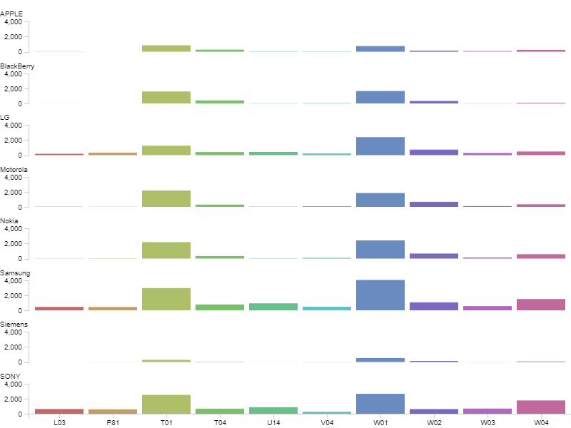
The number of patents has grown rapidly and gradually created technology gaps among major mobile phone companies. Samsung was more prominent in the patent number in many fields, such as printed circuits and connectors (V04), telephone and data transmission systems (W01), computer peripheral equipment (T04), TV and broadcast radio receivers (W03), and broadcasting, radio and line transmission systems (W02). As shown in the correspondence analysis results (Figure 10), these fields, V04, W01, T04, W03, W02, were closer to Samsung than others. Motorola, Nokia, and BlackBerry were with similar patent portfolios. Their patent portfolio focused on the technologies of the digital computer (T01), computer peripheral equipment (T04), and telephone and data transmission systems (W01). Besides, Apple Inc., Siemens, LG, and Sony focused on some specific technologies. For example, Apple Inc. focused on the development of the digital computer (T01) patents. Siemens was good at the technologies of telephone and data transmission systems (W01) and broadcasting, radio and line transmission systems (W02). Sony was good at the technologies of TV and broadcast radio receivers (W03), electro-(in)organic (L03), and audio/visual recording and systems (W04).

Figure 10 Correspondence analysis of mobile phone patents of 2005-2009
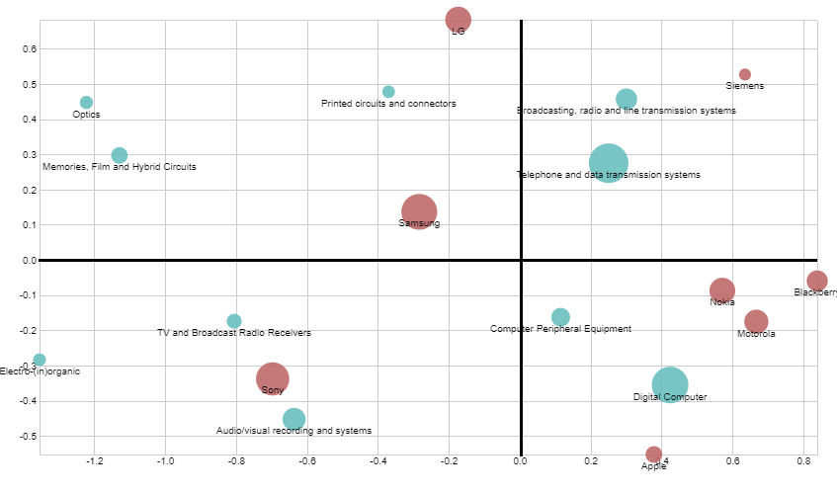
2010-2014: Mobile commerce stage
Figure 11 reveals the trend of mobile phone patents in the top ten fields by the years from 2010 to 2019. All mobile phone patents were included in this figure, including the patents owned by or not by the major mobile phone companies. As figure 11 indicates, in the early 2010s, the increased speed of mobile phone patent numbers was slowed down. In this period, most mobile phone patents belong to telephone and data transmission systems (W01), digital computer (T01), audio/visual recording and systems (W04), analogue and hybrid computers (T02), and broadcasting, radio and line transmission systems (W02). The gap between telephone and data transmission systems (W01) and T01 is close, which reveals that the importance of digital computer (T01) patents was continually increasing.

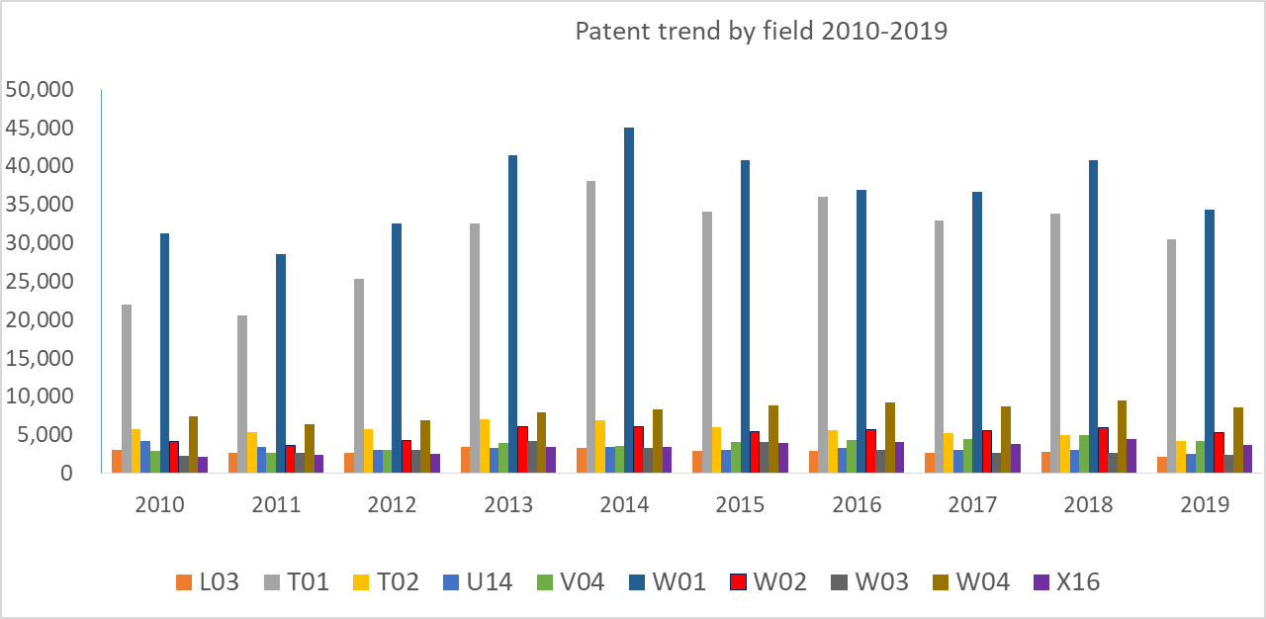
Figure 11 Patent trend by field in the period of 2010-2019

Except for the above leading players in the mobile phone field in the late 2000s, HTC, Huawei, and ZTE entered the market and played an active role in this period. During this stage, the technologies of telephone and data transmission systems (W01) and digital computer (T01) continued to be the two most important fields, as shown in figure 12. Audio/visual recording and systems (W04) had more technological breakthroughs in this stage. The number of patents audio/visual recording and systems (W04) patents exceeded that of Computer Peripheral Equipment (T04), especially for Samsung and Sony companies.

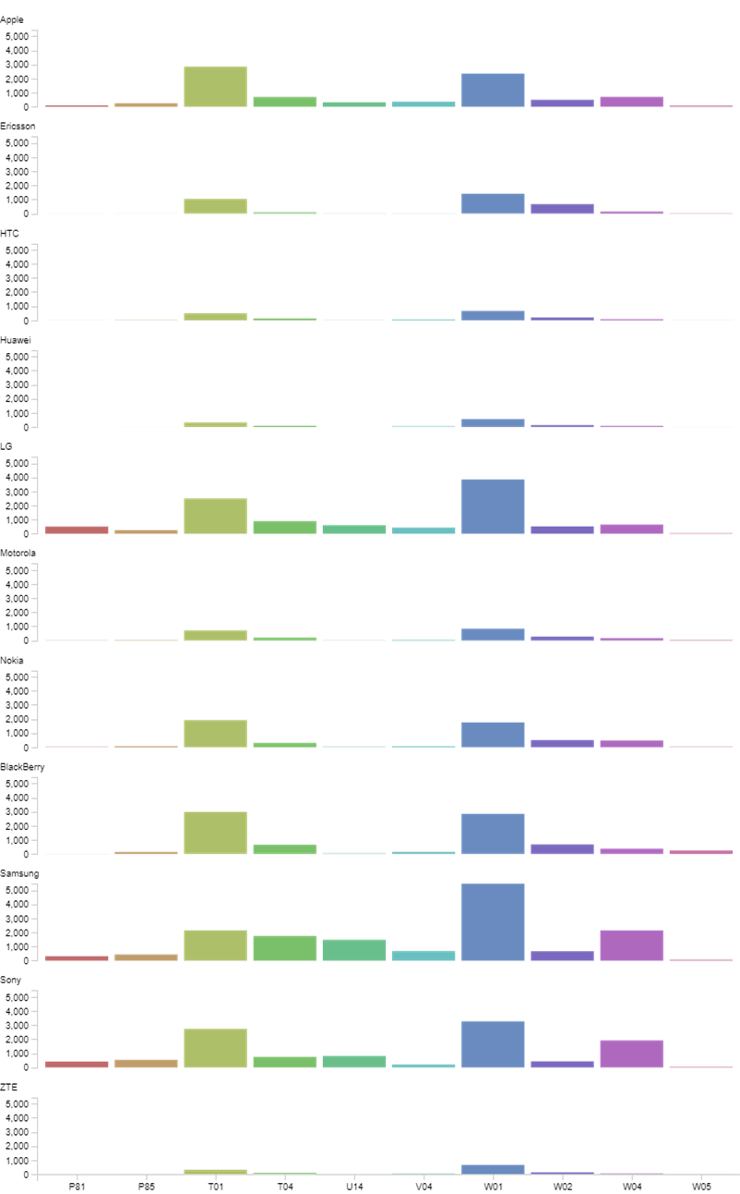
Figure 12 Patent portfolio in the period of 2010-2014
Figure 13 shows the scatter of major mobile phone companies and patent fields of correspondence analysis results in this period. In this period, the major mobile phone companies were farther away than in previous periods. They are distributed around the four quadrants in figure 13. Most major companies in this period developed their own unique patent portfolio for developing their technical features. Samsung and LG were closed and located in the first quadrant. Apple Inc., Nokia, and BlackBerry were close to each other and located in the third quadrant, and they invested more in the digital computer (T01) technologies than other companies. It shows that the three companies are good at digital logic system technology.

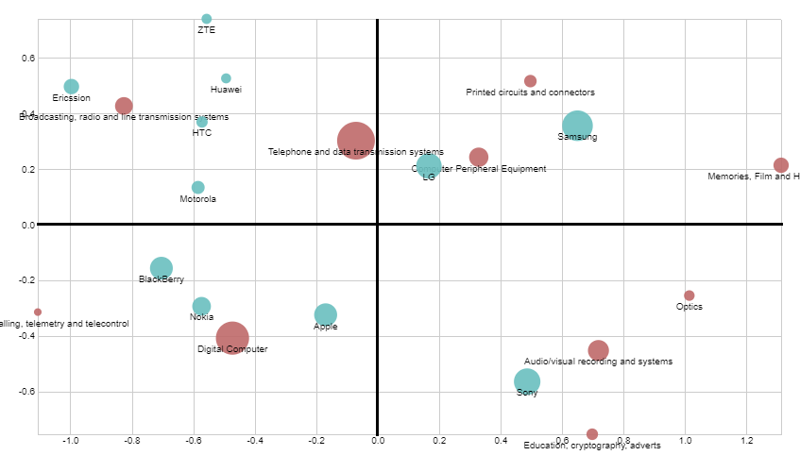
Figure 13 Correspondence analysis of mobile phone patents of 2010-2014

In the first quadrant, Samsung invested a higher proportion of computer peripheral equipment (T04), printed circuits and connectors (V04), memories, film and hybrid circuits (U14), and other technologies than other players. The above technologies in which Samsung made more effort than others belong to the component category. The fact was that although Samsung was Apple’s main competitor, Apple Inc. still outsourced some components or parts to Samsung since Samsung was with the expertise of mobile phone component manufacturers. The competitive and cooperative relationship between these two companies, like the co-opetition relationship proposed by Chen (2008), that two major companies maintain all-inclusive interdependent opposites, i.e., some actions and relationships were competitive in nature, and others were cooperative.

2015-2019: Intensive Competition Stage
In the late 2010s, most mobile phone patents belong to telephone and data transmission systems (W01), digital computer (T01), audio/visual recording and systems (W04), analogue and hybrid computers (T02), and broadcasting, radio and line transmission systems (W02). The increased speed of mobile phone patent numbers was slowed down or even decreased slightly. In this period, most mobile phone patents belong to telephone and data transmission systems (W01), digital computer (T01), audio/visual recording and systems (W04), broadcasting, radio and line transmission systems (W02), and analogue and hybrid computers (T02). The gap between telephone and data transmission systems (W01) and digital computer (T01) is close. This revealed that the importance of digital computer (T01) patent continually increased. In this period, we can find that the number of printed circuits and connectors (V04) patents increased. The number of printed circuits and connectors (V04) patents is close to analogue and hybrid computers (T02).
In the period, there was intense competition among mobile phone companies. The leading companies were Apple Inc., Samsung, Huawei, OPPO. In this stage, the primary patent fields were telephone and data transmission systems (W01), digital computer (T01), and audio/visual recording and systems (W04), as shown in figure 14. Technology of digital computer (T01) received attention from the leading companies, as its position in the corresponding analysis was very close to the origin of the coordinates. In other words, digital computer (T01) was the critical technology that every leading mobile phone company should focus on.
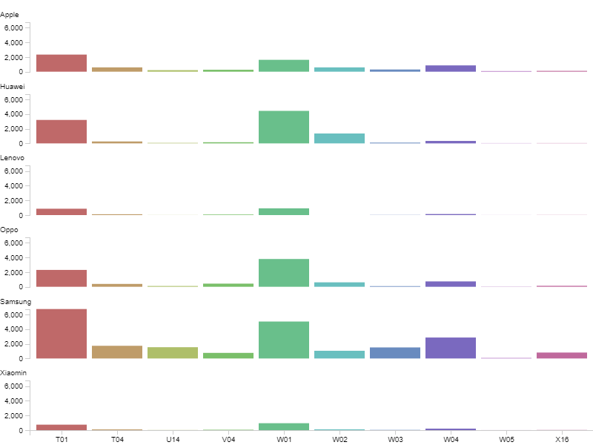
Figure 14 Patent portfolio in the period of 2015-2019

Apple Inc. was the closest to the essential mobile phone technology fields of telephone and data transmission systems (W01) than the other companies in figure 15. Samsung is located on the horizontal axis and held the shorter distance with most technology fields of computer peripheral equipment (T04), audio/visual recording and systems (W04), electrochemical storage (X16), TV and broadcast radio receivers (W03), and memories, film and hybrid circuits (U14). Apple Inc. and Samsung were leaders in mobile phones in this period; Apple Inc. was good at some core technologies of mobile phones, and Samsung was good at the other technologies related the mobile phones.

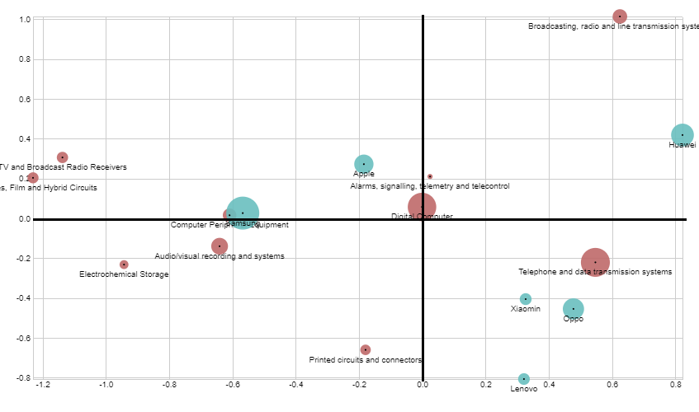
Figure 15 Correspondence Analysis of Mobile Phone Patents of 2005-2009

DISCUSSION
The mobile phone is already a necessity for most people and has been an important technological innovation for the past few decades. This single product type also cultivates enormous employment and sustainable economic development in many countries. Some mobile phone giants continually receive massive revenue from the sales of mobile phones. However, some mobile phone pioneers in the 1990s and early 2000s, such as Nokia, Siemens, NEC, and Ericsson, quit the market or were no longer key players in the mobile phone industry. The pioneer and legendary mobile phone grants no longer held their competitive advantage.
The study of mobile phone technology competition can help us to realize the influence of technology evolution on competitive competence. New challengers, such as Apple iPhone, earn market share through their advanced technology and innovative design. Apple Inc. is now the number one mobile company, and iPhone has been the top sale mobile phone in recent years. However, Apple Inc. was the late-mover that entered the mobile phone market as late as 2007. The development of the mobile phone industry is a massive example of revealing the sustainability of competitive advantage and exploring the role of the patented invention in the competitive position of technology products.
The current study analyses the rising and fall of mobile phone companies from the perspective of patent analysis. We summarize that in the early 1990s, the major technology fields of mobile phones were telephone and data transmission systems and broadcasting, radio, and line transmission systems. In the 2000s, the major technology fields changed to telephone and data transmission systems, digital computers, audio/visual recording and systems, analogue and hybrid computers, and broadcasting, radio, and line transmission systems. Digital computers, audio/visual recording and systems, analogue and hybrid computers, and broadcasting were new technology fields that mobile phone companies focused on. In the 2000s, the mobile phone is not just a phone but a smartphone with powerful features. If mobile phone companies focused only on the legend fields of the 1990s, they would die out because their product would not meet the market need.
In the 2010s, the mobile phone was not just a smartphone; Instead, it became a computer with a tiny size. The focus fields change to peripheral computer equipment, audio/visual recording and systems, electrochemical storage, TV and broadcast radio receivers, and memories, film and hybrid circuits. In this stage, mobile phone companies had to launch a mobile phones with powerful features like computers. People use the mobile phone as a computer rather than just a portable telephone.
By correspondence analysis, the study figures out the technological competitive advantage of these mobile phone companies in different periods. Understanding the rise and fall of mobile phone companies from the perspective of patented innovation can help managers realize the dynamic nature of technology competition in technology product innovation.
The rapid technological development of China-based high-tech companies is now a significant threat to U.S.-based companies. Thus, since 2020, the US Federal Government had initiated some actions again China-based companies from the side of chip supply (Baek, 2022; Miller, 2022). These actions are named the Chip War. In future studies, academics and industry practitioners may observe the competitions during the Chip War period. These China-based mobile phone companies, such as Huawei, Lenovo, OPPO, and Xiaomin, have to develop their own technique capacity and reduce their dependency on U.S.-based and European-based companies. If they can develop their unique technology capacity that creates a competitive advantage that matches customer needs, maybe the mobile phone industry would start a new round of mobile phone evolution. In contrast, if these China-based mobile phone companies cannot survive after the Chip Wars, these China-based companies would not play important roles in the global mobile phone industry. U.S.-based and European-based companies may play dominant roles.

REFERENCES
Baek, D. (2022). “Chip War” Between US and China: Restructuring the Trans-Pacific Semiconductor Value Chain. Journal of Global and Area Studies, 6(3), 25-54. https://doi.org/10.31720/JGA.6.3.2
Blind, K., Pohlisch, J., & Rauber, J. (2022). Patenting and standardization: Similarities and differences based on firms’ strategic motives and experienced barriers. Journal of Engineering and Technology Management, 65, 101699. https://doi.org/10.1016/j.jengtecman.2022.101699
Calantone, R. J., Di Benedetto, C. A., Hakam, A., & Bojanic, D. C. (1989). Multiple multinational tourism positioning using correspondence analysis. Journal of Travel Research, 28(2), 25-32. https://doi.org/10.1177/004728758902800207
Chen, M. J. (1996). Competitor analysis and interfirm rivalry: Toward a theoretical integration. Academy of Management Review, 21(1), 100–134. https://doi.org/10.5465/amr.1996.9602161567
Chen, M. J. (2008). Reconceptualizing the competition-cooperation relationship: A transparadox perspective. Journal of management inquiry, 17(4), 288-304. https://doi.org/10.1177/1056492607312577
Clark, D. J., & Nilssen, T. (2020). Creating balance in dynamic competitions. International Journal of Industrial Organization, 69, 102578. https://doi.org/10.1016/j.ijindorg.2019.102578
Ernst, H. (2003). Patent information for strategic technology management. World Patent Information, 25(3), 233–242. https://doi.org/10.1016/s0172-2190(03)00077-2
Greenacre, M. J. (1984). Theory and application of correspondence analysis. London: Academic Press.
Kaimann, D., & Hoyer, B. (2019). Price competition and the Bertrand model: the paradox of the German mobile discount market. Applied Economics Letters, 26(1), 54-57. https://doi.org/10.1080/13504851.2018.1436141
Miller, C. (2022). Chip War: The Fight for the World’s Most Critical Technology. Simon and Schuster.
Pantano, E., Priporas, C. V., Sorace, S., & Iazzolino, G. (2017). Does innovation-orientation lead to retail industry growth? Empirical evidence from patent analysis. Journal of Retailing and Consumer Services, 34, 88-94. https://doi.org/10.1016/j.jretconser.2016.10.001
Rosar, F., & Mueller, F. (2015). Negotiating cultures in corporate procurement. Journal of Economic Behavior & Organization, 117, 259-280. https://doi.org/10.1016/j.jebo.2015.06.012
Shih, M. J., Liu, D. R., & Hsu, M. L. (2010). Discovering competitive intelligence by mining changes in patent trends. Expert Systems with Applications, 37(4), 2882-2890. https://doi.org/10.1016/j.eswa.2009.09.001
Souza, E. L., Leal, I. L., Umsza-Guez, M. A., & Machado, B. A. (2021). Evaluation of the Technological Potential of Grape Peels through Patent Document Analysis: Agro-industrial Waste with Biotechnological Potential. Recent Patents on Nanotechnology, 15(1), 35-46. https://doi.org/10.2174/1872210514999200730172649
Trautrims, A., MacCarthy, B. L., & Okade, C. (2017). Building an innovation-based supplier portfolio: The use of patent analysis in strategic supplier selection in the automotive sector. International Journal of Production Economics, 194, 228-236. https://doi.org/10.1016/j.ijpe.2017.05.008
Wang, L., & Li, Z. (2021). Knowledge flows from public science to industrial technologies. The Journal of Technology Transfer, 46, 1232-1255. https://doi.org/10.1007/s10961-019-09738-9
Wang, X., Zhang, X., & Xu, S. (2011). Patent co-citation networks of Fortune 500 companies. Scientometrics, 88(3), 761-770. https://doi.org/10.1007/s11192-011-0414-x
Webber, P. M. (2003). Protecting your inventions: the patent system. Nature Reviews Drug Discovery, 2(10), 823-830. https://doi.org/10.1038/nrd1200
Yang, X., Yu, X., & Liu, X. (2018). Obtaining a sustainable competitive advantage from patent information: A patent analysis of the graphene industry. Sustainability, 10(12), 4800. https://doi.org/10.3390/su10124800

Dr. Yann-Jy Yang is an Assistant Professor at Center for General Education at National Central University in Taiwan. She received her PhD in Management from National Chengchi University in Taiwan. Her current research interests include Intellectual Property Management, Entrepreneurship, and Innovation Management. Before joining National Central University, she worked as a researcher for Industrial Technology Research Institute (ITRI). She also had worked at MingDao University, National Tsing Hua University, and Chihlee University of Technology. She is also an inventor of several Taiwanese and US patents.

