**Exploring the Landscape of Islamic Management Research Through Bibliometric Analysis: Insights and Implications**

Muhamad Subhi Apriantoro*

Universitas Muhammadiyah Surakarta, Indonesia

E-Mail: [msa617@ums.ac.id](mailto:msa617@ums.ac.id)

Ilham Widhi Susanto

Universitas Muhammadiyah Surakarta, Indonesia

E-Mail: [i000200129@student.ums.ac.id](mailto:i000200129@student.ums.ac.id)

**ABSTRACT**

The exploration of Islamic management holds significant scholarly value as it can enhance comprehension and scholarship regarding management methodologies aligned with Islamic values. This study analyzes and presents a visual representation of the progression of scholarly papers about Islamic management. This study is based on research on Islamic management in the Scopus-indexed database from 1971- 2022. We analyze this discipline's publication trends, co-authorship networks, and bibliographic coupling using advanced tools like VOS Viewer and R Studio. This study only considers databases indexed by Scopus, ignoring other reputable international indexers. We found that Islamic management studies focus on three areas: Organization and management as a tool, risk management in Islamic finance, and the effects of ethical management of Islam on conflict resolution. The findings of this study are significant in paving the way for future research and providing projections on areas that need a more significant portion of accelerated development. Decision-makers can utilize this research to implement innovative and sustainable strategies. Additionally, researchers can use this article as a guide to understand future research developments and orientations in Islamic management.

**Keywords:** Literature review, Management, Finance, Islamic management, Bibliometric citation analysis

**INTRODUCTION**

Islam is a comprehensive religion that covers every aspect of human activity and is between a uniform or multicultural society that contains many perspectives and gives rise to societal concepts (Hambali et al., 2022). Islam is not a religion that only focuses on the personal lives of individuals but also includes and guides human interaction and activities in daily life (Ghani & Apriantoro, 2023).

Islamic management is the basis for daily activities and activities to make life more organized and coherent. Islamic management is also essential to developing flexibility. This research also records the development and track record of Islamic Management. Islamic management is also one of the things that must be learned, which is consistency or Istiqomah in carrying out something ongoing. It is essential because it is consistent and organized and can also reduce the risks of possible things that can hinder human activities. Islamic Management also makes human morality more organized. It has a high sensitivity to something that happens in its environment. Notably, it reduces risks in activities associated with financial issues (Kvasnytska et al., 2023).

Islamic management also plays an essential role in organizing a system. Islamic management can also perform functions based on Islamic teachings to achieve specific goals. Islamic management is essential because it concerns human behavior and actions. The importance of Islamic management is also a characteristic of humans who accept development but still filter the values of sense teachings that apply. Islamic management is a system that is very open and friendly to anyone who does not know what religion, making this system a benchmark or a reference (Selvarajah et al., 2018).

Islamic management differs from conventional management in several key aspects. Islamic management is centered on Islamic ethical values, the goal of balance between material and spiritual, fair decision-making, and risk management by sharia. Conventional management focuses more on financial return, hierarchical decision-making, and financial strategy. Islamic management also emphasizes leadership based on morals and ethics, corporate social responsibility, and long-term thinking, while conventional management often emphasizes technical professional development and short-term results. Although these differences exist, many organizations try to integrate Islamic management principles with conventional practices according to their values (Shahab et al., 2022).

Islam itself mentions that management is the science of order, the science of discipline, and Islam regulates human life towards greatness, life now (the world) as well as in future life and the last day how vital management and Islam are. Management has existed since humans existed. Why is it the same age as the age of a human being? Human beings in everyday life are inseparable from the principles of management, whether realized directly or indirectly (Arviah, 2020). As Muslims, management is certainly not new because Islam teaches its people to manage everything as Allah says in Sura An-Nisa verse 103, "Truly, prayer is a timed obligation upon people of faith." From this verse, it can be learned that the order of prayer for Muslims is only regulated, especially in other matters that certainly need management (Zain & Zakaria, 2022). This passage is about religion, but its concepts can also be applied to business and organization administration. This passage emphasizes time management and the significance of sticking to schedules in all facets of life. Organizational leaders must respect project deadlines, meetings, and other obligations. In addition, this verse emphasizes religious discipline, which is vital to business and organizations. This discipline requires good performance of responsibilities and commitments, which boosts productivity. Organizational and corporate management can benefit from priority setting, time management, and planning to efficiently allocate resources and achieve goals.

Managing something will undoubtedly have a positive impact, such as regular time, organized work, organized lifestyle, and increased quality as a foundation of prayer. For example, the destruction of the tourism world when COVID-19 peaked and the pandemic made it difficult for the tourism sector to operate and almost entirely paralyzed. However, with health protocols and improving conditions, the tourism world certainly needs proper crisis management so that the tourism sector can bounce back after its downturn due to the pandemic. This is an example that control is essential in life (Sofyan et al., 2022).

The conclusion that can be drawn is that management has a very decisive role in the success of a program. With good management, an organization or business can succeed. However, when the general notion of management is given the predicate "Islam," then its connotations become limited following the rules applicable in Islamic teachings. Thus, "Islamic management" is the process of using resources effectively and responsibly to achieve the goals that the Organization has set according to standard Islamic teachings and to impose attitudes or morals according to Islamic teachings (Faisal, 2021).

Carefully assessing findings from existing research has excellent significance(Md Husin et al., 2023). This opens the door to further research and advises policymakers on areas that need further development. This evaluation process is highly dependent on the availability of scientific research data and the data's accuracy(Kazak, 2023). One tool that has a crucial role in evaluating the results of scientific research is bibliometric indicators. This indicator analyzes the relationship between science and technology, maps various disciplines, tracks knowledge development in specific fields, and becomes an essential reference in future strategic planning.

This study aims to identify the progress and orientation of research in Islamic management in publications listed in the Scopus database and to plan research themes and future directions.

**RESEARCH METHODS**

This research uses bibliometric methods to produce quantitative results on Islamic Management literature. Bibliometric analysis, colloquialized with content analysis, is becoming increasingly familiar and well-known among scholars (M S Apriantoro et al., 2023; Muhamad Subhi Apriantoro, Kaloka, et al., 2023; Muhamad Subhi Apriantoro et al., 2024; Muhamad Subhi Apriantoro & Diniyah, 2024). Descriptive, integrative, systematic, or meta-analytical reviews combine with bibliometric reviews to convey quantitative aspects of the literature, ensuring reliability and validity (Martnez-Climent et al., 2018).

In the first stage, the researcher examines a literature review that aligns with the theme to examine the similarity of research with bibliometric topics and aims to determine keywords according to the scope discussed in the study (Muhamad Subhi Apriantoro, Muthoifin, et al., 2023).

The next step involves identifying relevant data and excluding irrelevant information from the 2023 Scopus database to understand the research comprehensively. This can be achieved by filtering the publication column using a specific code. The data for this study was collected by conducting keyword searches on the Scopus electronic database, explicitly focusing on titles, keywords, and abstracts of articles related to Islamic management (M S Apriantoro et al., 2023).

The third stage,at this stage, is to analyze data documents and visualization through VOSviewer and data processing using Microsoft Excel, with analysis of writing (Co-authorship) and keywords (co-occurrence). For example, in this study (Co-authorship) and (Co-occurrence) were used to map developments and visualize related to this study. This entire procedure can be seen in Figure 1.

**Analysis Tools**

In obtaining results to represent data processing in citation analysis, document content, and networks, the author uses VOSviewer data processing software, Microsoft Excel, and Biblioshiny. The method used to research the development around Islamic management is bibliometric and produces quantitative data related to the development of Islamic management research. Bibliometric analysis combined with data interpretation in research(Muhamad Subhi Apriantoro & Wijayanti, 2022).

**Analysis Type**

Researchers use several stages or steps to understand the development of topics in this analysis (Figure 1). First, the researcher conducts a universal analysis. This process filters and extracts universal information in the form of data from year to year. Researchers also discuss critical perspectives based on literature, such as the interrelationships between authors, countries of origin, and affiliations. The two sections discuss the most cited references, documents, and sources, as well as the topics and problems the author analyzes. Next, the three authors researched and conducted network analysis using bibliographies. In the last section, the author uses hierarchical analysis (dendrogram) to ensure accuracy and accuracy.

**Figure 1**  *The Flowchart of the Research Procedure*

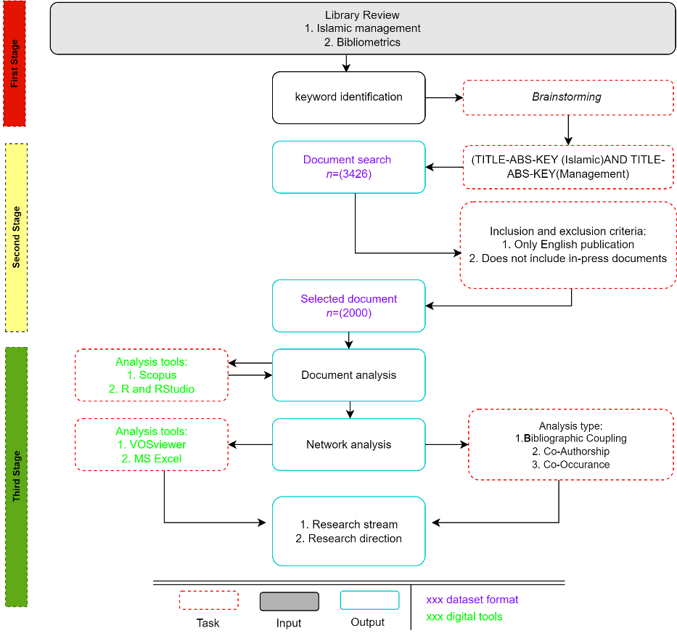

Table 1 summarizes the data gathered from a sample of 2000 documents spanning 12 years. This dataset comprises 810 books, several journals, and 5227 authors. During the review process, a total of 4093 keywords were considered. The table also illustrates the distribution of documents published each year between 2010 and June 2022. Islamic management has been a topic of interest since 2010.

**Table 1** *General of the Review*

|  |  |
| --- | --- |
| **Description** | **Results** |
| Documents | 2000 |
| Sources (Journals, Books, etc.) | 810 |
| Keywords Plus (ID) | 4093 |
| Author's Keywords (DE) | 5719 |
| Period | 1971 – 2022 |
| Average citations per document | 8.101 |
| Authors | 5227 |
| Author Appearances | 6189 |
| Authors of single-authored documents | 365 |
| Authors of multi-authored documents | 4862 |
| Single-authored documents | 380 |
| Documents per Author | 0.383 |
| Authors per Document | 2.61 |
| Co-Authors per Documents | 3.09 |
| Collaboration Index | 3 |
| Article | 2000 |

These data constitute a substantial body of research literature in an unidentified field from 2010 to 2022. This collection contains 2,000 published documents from 810 unique sources, reflecting the variety of references utilized by researchers. In addition, there are 4093 additional keywords (Keywords Plus) and 5719 author-generated keywords (Author's Keywords), indicating that this literature explores a vast array of concepts and topics. The relatively high citation rate, with an average of 8,101 citations per document, demonstrates the importance and influence of this body of literature within the academic community. The data also indicate a high level of collaboration, with 5227 authors contributing to creating these documents. Except for 365 documents, the majority of the documents were the consequence of collaboration. These outcomes demonstrate the predominance of collaboration in this area of research. These data depict a highly cooperative research field with an average of 3 authors per document, a collaboration index of 3, and an average of 0.383 documents per author. All of the documents in this collection are scientific articles, indicating that scientific article research predominates in this body of literature. Overall, these data shed light on the significance of collaboration and the applicability of research in this as-yet-unnamed field while emphasizing the diversity of topics explored in this literature.

**MOST INFLUENTIAL AUTHORS, AFFILIATIONS, AND COUNTRIES**

The developments experienced by articles in this field are associated with societies, scientific communities, authors, references or sources, and affiliations—Figure 2. The graph explains that from year to year, it changes rapidly recorded from 1971, and titles related to Islamic management have become a topic researched by researchers. From that year, it explains a graph that shows very significant changes because from 1971, from only 1 document and continuously increasing until 2019 to the highest peak of 270 documents indicates that the topic each year has its circle to be researched and this topic is flexible and keeps up with the times. This topic is increasing yearly because it makes people curious about Islamic management. This topic is also one of the essential variables in interest in Islamic finance and organizing behavior in Islamic finance (Allah Pitchay, 2022). Islamic management became one of the interesting topics discussed in a 2019 study. This particular subject matter saw a surge in publications, reaching 270 documents. This spike coincided with the onset of the COVID-19 pandemic, indicating that the pandemic had a macroeconomic impact that also affected the domain of Islamic management. During that year, there was a heightened focus on regulating and managing finances and behavior, with Islamic management emerging as a viable option. The data's graphical representation indicates that many authors published works on Islamic management during this period.

**Figure 2** *Document by Year*

These data illustrate the evolution of management throughout history. Since it first appeared in 1971 with a single document, interest in the topic has grown substantially. The graph illustrates the resilience and relevance of Islamic management as a field of study responsive to social and contemporary issues, with the number of publications consistently increasing. The increase in annual publications reflects researchers' high interest and curiosity in comprehending and applying Islamic principles in management. The publication of 270 Islamic management-related documents in 2019 coincided with the onset of the COVID-19 pandemic, which heightened the significance of Islamic management. This suggests that the pandemic has a significant macroeconomic impact that extends to the Islamic management domain, mainly regarding financial and behavioral regulations. In addition, graphical data demonstrates the high level of collaborative writing activity among numerous authors in Islamic management literature. Islamic management is a crucial aspect of Islamic finance and coordinating behavior within the context of Islamic finance. In conclusion, these data demonstrate Islamic management's development, resilience, and significance in research and its impact on social issues such as the COVID-19 pandemic.

In Figure 3, Islamic management is one of the unique topics journal writers discuss. Recorded or recorded data in the grouping analysis on behalf of Hassan, M.K. became one of the authors who produced many works or documents of publication, as many as 15 documents discussing Islamic Management, in figure 1. It was elucidated that in 2019, the highest number of publications on Islamic management were produced, with the tally reaching almost 300 documents. Specifically, 270 documents were recorded, of which 15 were either authored or co-authored by Hassan, M.K. In the second position, Oseni, U.A. wrote as many as ten journals on topics related to Islamic management, signifying that the research on this subject is still in demand and continues to be pursued, even though numerous articles or journals on Islamic management may still be pending publication or in the queue of Scopus system.

It is conceivable that the topic of Islamic management will remain a subject of interest and discussion among journal authors due to its profound connection with people's lives, finances, and behaviors in organizations, and its ability to organize finance in a more Islamic concept, which is one of the reasons why this subject attracts wide attention from both domestic and foreign writers. In addition, Islamic management is distinctive in that it diverges from conventional management, and this difference generates perennial interest and discourse on the topic.

**Figure 3** *Most Relevant Authors in Islamic Management*

Figure 4 shows that most of the Affiliates are from the International Islamic University Malaysia, which has 129 documents on Islamic management. It is necessary to know that its own country, Malaysia, has used Islamic law-based rules in its financial system so that students, lecturers, and even researchers can follow whether it is following the provisions of Islam. This is also a correction of the Malaysian government's regulation policy through research that has been affiliated with it. The next order also comes from Malaysia, namely Mara Technology University or Shah Alam, which is affiliated with 91 documents again. This is also a reference for regulating governance in Malaysia itself because it is based on Islamic finance, which is also included in the topic of Islamic Management. Islamic-based financial governance can indirectly foster significant growth, proving that the Malaysian state is more prosperous in Islamic finance-based finance and implementing Islamic management. (Naz & Gulzar, 2022)Mara Technology University, or Shah Alam, also often conducts research with Islamic universities in Indonesia to discuss Islamic finance.

**Figure 4** *Most Relevant Affiliation*

Figure 5 explains that Malaysia is the only country that has published a journal on Islamic management, and its publications reach 621 journals. Malaysia itself is a country that implements Islamic-based finance or is based on Islamic law, making topics about Islamic Finance, and one of the most important is Islamic Management. By implementing Islamic management, the Malaysian state can organize finance so as not to *be chaotic* financially. Many Chinese in Malaysia can also introduce this Islamic management system by organizing and adopting Islamic financial methods, one of which is Islamic management(Bouheraoua & Djafri, 2022). Of course, this moment of being a very recent study by the researchers itself is one of the reasons why this topic has become the most talked about in Malaysia. This is a new area of study for the researchers themselves, which is why this topic is discussed a lot in Malaysia. Muslims are not the only ones who are interested in Islamic financial control. Our non-Muslim brothers and sisters are familiar with and use Islamic Management practices (Saiti et al., 2022). Many researchers also directly seek affirmations from managers in Malaysia for the practice of the application of Islamic Management itself.

The second most populous country in Islamic management research is Indonesia because Indonesia has the largest population of Muslims in Southeast Asia and also because of the pluralism that exists in Indonesia, which, when talking about religion, always gets a very diverse response from the public, making researchers also discuss this topic and the data shows this topic to be the second most populous after Malaysia, which is 358. For the third data, namely, From the state of Iran, the state of Iran itself is a Muslim country that is also prone to conflict. Based on the Muslim state of Iran, there are also many studies on Islamic management, one of which is to regulate everyone's behavior always to be organized following the teachings of Islam. Even though conflicts have recently hit the Iranian state or are often hit by security issues, works still appear on the surface as a track record that governance in the field of finance is still based on Islamic finance, which adheres to Islamic management. Finally, the fourth-placed country, a predominantly protestant country, is very open to studying business organizations based on Islamic management. There are 180 researchers from the United Kingdom.

**Figure 5** *Most Relevant Country*

Bradford's law filters and estimates reference to be exponentially reduced in a journal. One is a formulation, when you sort the journal into unspecific parts and produce the journal with the most references in Table 2.

The Bradford Law methodology in bibliometrics is employed by analyzing their publication output to ascertain the core journals within a specific discipline. The initial stage involves gathering and publishing data from diverse journals and organizing them according to productivity. Subsequently, the entire number of articles is tallied and partitioned into three distinct zones according to productivity levels: a core zone, a zone with somewhat lower productivity, and a zone with the least productivity. By adopting this approach, researchers can concentrate their efforts on the most crucial resources within their respective fields, thereby streamlining the decision-making process and optimizing the allocation of research resources.

**Table 2**  *Bradfod's Law*

|  |  |  |  |  |
| --- | --- | --- | --- | --- |
| Source | Rank | Freq | cumFreq | Zone |
| Journal of Islamic Accounting and Business Research | 1 | 76 | 76 | Zone 1 |
| International Journal of Islamic and Middle Eastern Finance and Management | 2 | 68 | 144 | Zone 1 |
| Journal of Islamic Marketing | 3 | 56 | 200 | Zone 1 |
| Eastern Mediterranean Health Journal | 4 | 40 | 240 | Zone 1 |
| International Journal of Environmental Science and Technology | 5 | 30 | 270 | Zone 1 |
| International Journal of Supply Chain Management | 6 | 26 | 296 | Zone 1 |
| Advances In Environmental Biology | 7 | 22 | 318 | Zone 1 |
| International Journal of Innovation, Creativity And Change | 8 | 22 | 340 | Zone 1 |
| Isra International Journal of Islamic Finance | 9 | 21 | 361 | Zone 1 |
| Humanomics | 10 | 19 | 380 | Zone 1 |

Based on the data provided, Bradford's Law was used to categorize journals into three zones based on publication frequency. Zone 1, which is the core zone, includes the top three journals with the highest publication frequency, namely "Journal of Islamic Accounting And Business Research," "International Journal of Islamic And Middle Eastern Finance And Management," and "Journal of Islamic Marketing," which had 76, 68, and 56 articles respectively, for a total of 200 articles. Meanwhile, although still in Zone 1, other journals have a lower publication frequency and contribute less significantly to the total number of articles in this field. This helps identify core journals with higher publication productivity and guides researchers in selecting relevant reading sources.

**CITATION ANALYSIS**

Citations analysis is a step that impacts and affects the quality of an article, as determined by the number of times other authors have mentioned and referenced the article in the work of those authors. This analysis lists multiple calculations or statistical data of an article in another work to measure the impact of a publication or author (MacRoberts & MacRoberts, 1989). This section analyzes citations from documents, references, and sources in addition to the influence of sources and authors. Table 3 discusses most locally and globally cited documents. Table 4 and Table 5 discuss the impact of authors and sources, respectively. It can be seen that the citations of the author Hassan MK have a total of 296 citations, which also significantly impacted the research and dominated it. The author also sees that the Journal of Islamic Accounting And Business Research has the highest impact on Table 5. The Journal of Islamic Accounting And Business Research is the most relevant journal on this topic

**Table 3** *Shows the Most Locally and Globally Cited Documents*

|  |  |  |  |  |  |
| --- | --- | --- | --- | --- | --- |
| Author | Year | LC | GC | Ratio (%) | Document |
| Čihák M | 2010 | 25 | 392 | 6.38 | Islamic Banks and Financial Stability: An Empirical Analysis |
| Wilson Jaj | 2011 | 23 | 344 | 6.69 | The challenges of Islamic branding: navigating emotions and halal |
| Quttainah Ma | 2013 | 17 | 76 | 22.37 | Do Islamic Banks Employ Less Earnings Management? |
| Abu Hussain H | 2012 | 16 | 47 | 34.04 | Risk management practices of conventional and Islamic banks in Bahrain |
| Tieman M | 2011 | 14 | 172 | 8.14 | The application of Halal in supply chain management: In-depth interviews |
| Archer S | 2010 | 13 | 45 | 28.89 | Supervisory, regulatory, and capital adequacy implications of profit‐sharing investment accounts in Islamic finance |
| Almutairi Ar | 2017 | 12 | 50 | 24.00 | Corporate governance: Evidence from Islamic banks |
| Elnahass M | 2014 | 12 | 60 | 20.00 | Loan loss provisions, bank valuations, and discretion: A comparative study between conventional and Islamic banks |
| Abdullah M | 2011 | 11 | 36 | 30.56 | Operational risk in Islamic banks: examination of issues |
| Ali Aj | 2010 | 11 | 55 | 20.00 | Islamic challenges to HR in modern organizations |

*Notes*. LC: local citation, GC: global citation

Locally cited references, sometimes known as "internal citations" or "intra-journal citations," are derived from publications published within the same journal or conference as the study under consideration. The significance of these references lies in their ability to offer valuable insights into the influence of the publication within its immediate research community, highlighting its importance within that particular context(Chen & Song, 2019).

Conversely, internationally recognized sources, sometimes called "external citations" or "inter-journal citations," are derived from scholarly articles or conference proceedings distinct from the publication in which the examined paper is hosted. The significance of these citations lies in their representation of the paper's effect extending beyond its specific scientific community, indicating its broader worldwide impact (Nielsen & Andersen, 2021).

An exciting idea that emerges is that studies with a high ratio of cited literature tend to have a sharper focus on specific issues in Islamic banking. For example, Abu Hussain H's 2012 study on "Risk management practices of conventional and Islamic banks in Bahrain" had the highest cited literature ratio, reaching 34.04%. This indicates that the risk management issue in Islamic banking is becoming critical and relevant. The implication is the need for further research and action focused on improving risk management practices within Islamic financial institutions.

On the other hand, there are also studies with a lower ratio of cited literature, such as Tieman M's 2011 study on "The application of Halal in supply chain management." Although this ratio is lower, the topic of this study is interesting because it combines aspects of Islamic banking with the concept of halal supply chain, which is an essential issue in the food and beverage industry. An interesting idea is how Islamic banking practices can impact the halal supply chain, which may have broader implications beyond the financial sector.

Moreover, some studies highlight corporate governance issues in Islamic banking, such as Almutairi Ar's research in 2017. This raises questions about the importance of effective governance in Islamic-based financial institutions and whether different governance models are needed in this context.

Aside from the content aspect, the analysis also reflects the development of research in Islamic finance over time. Most of the studies analyzed were from 2010 to 2013, with the most recent study in 2017. This may reflect the interest and growth of research in this area and suggest that Islamic banking remains relevant and exciting to researchers.

**Table 4** *Authors Impact*

|  |  |  |  |  |  |  |
| --- | --- | --- | --- | --- | --- | --- |
| Author | H Index | G Index | M Index | Total Citation | No of Publication | Publication Year |
| Hassan Mk | 9 | 15 | 0.75 | 296 | 15 | 2011 |
| Oseni Ua | 5 | 7 | 0.455 | 57 | 10 | 2012 |
| Alam Mk | 6 | 9 | 2 | 90 | 9 | 2020 |
| Hassan R | 5 | 7 | 0.417 | 55 | 9 | 2011 |
| Mohamad S | 4 | 8 | 0.364 | 79 | 9 | 2012 |
| Abdul Rahman A | 1 | 1 | 0.333 | 4 | 1 | 2020 |
| Sukmana R | 3 | 3 | 1 | 14 | 8 | 2020 |
| Ahmad K | 4 | 7 | 0.333 | 76 | 7 | 2011 |
| Ali S | 3 | 4 | 0.429 | 18 | 7 | 2016 |
| Rusydiana As | 3 | 5 | 0.6 | 35 | 7 | 2018 |

This study demonstrates various researchers with varying H-Index and M-Index values, illuminating differences in the impact and quality of their scientific community research. Researchers with a high H-Index, such as Hassan Mk, significantly impact the scientific community, as indicated by the frequency with which other scientists cite their work. Meanwhile, researchers such as Sukmana R and Rusydiana As, who have a high M-Index, describe the ability to accomplish a significant impact with a relatively small number of publications, often considered an indication of high research quality. However, this data also emphasizes the significance of considering the context and applicability of research, as the impact of research cannot always be measured solely by statistics. Variations in research productivity and influence between researchers can be influenced by several factors, such as the field of research in which they are engaged, their research foci, and the duration of time they have spent conducting research. This information provides insight into researchers' diversity and contributions to the research world.

**Table 5** *Sources Impact*

|  |  |  |  |  |  |  |
| --- | --- | --- | --- | --- | --- | --- |
| Source | H  Index | G  Index | M Index | Total Citation | No of Publication | Publication  Year |
| Journal of Islamic Accounting and Business Research | 11 | 18 | 0.9167 | 491 | 78 | 2011 |
| International Journal of Islamic and Middle Eastern Finance and Management | 13 | 20 | 1.0833 | 569 | 64 | 2011 |
| Journal of Islamic Marketing | 18 | 32 | 1.5 | 1114 | 55 | 2011 |
| Eastern Mediterranean Health Journal | 8 | 11 | 0.7273 | 201 | 41 | 2012 |
| International Journal of Environmental Science and Technology | 17 | 26 | 1.7 | 708 | 30 | 2013 |
| International Journal of Supply Chain Management | 3 | 3 | 0.5 | 21 | 26 | 2017 |
| Isra International Journal of Islamic Finance | 7 | 9 | 1.1667 | 104 | 23 | 2017 |
| Advances In Environmental Biology | 3 | 6 | 0.25 | 43 | 22 | 2011 |
| International Journal of Innovation, Creativity, and Change | 1 | 4 | 0.25 | 19 | 22 | 2019 |
| Humanomics | 11 | 16 | 0.9167 | 276 | 17 | 2011 |

The provided data offers valuable insights into various academic journals and the metrics employed to assess their effect and productivity. The scholarly publication known as the "Journal of Islamic Marketing" distinguishes itself through its notable H-Index and G-Index metrics, which mark its substantial influence within academic literature. Furthermore, the considerable M-Index and the total citation count of 1114 indicate that this journal has had a significant influence despite its limited publication output. In contrast, the scholarly magazine known as the "Journal of Islamic Accounting and Business Research" has notable production, boasting the highest volume of articles, totaling 78. The data also demonstrates disparities in the journal's influence based on the discipline, as evidenced by the lower indices of the "International Journal of Supply Chain Management."

**NETWORK ANALYSIS**

**Bibliographic Coupling**

The author mapped using 451 bibliometrics articles about Islamic management using VOSviewer software (Figure 6). VOSviewer is an application used to apply mapping and clusters in visualizations in images (Yadav et al., 2022). The author uses analysis with units of analysis with documents and methods by being a fractional analysis during analysis by combining a Bibliography. The setting author gives the setting in the minimum number of citations for a paper becomes ten sets and obtains 451 articles. VOSviewer also reads and visualizes images, as shown in Figure 5. As well as can be identified with multiple "clusters," and there are 12 "Clusters." Cluster 1 is denoted in red and has 47 items. Cluster 2 has a dark green color with 45 items in it. Cluster 3 is a dark blue color with 36 items in it. Cluster 4 has a yellow color, and there are 35 items. Cluster 5 with a color of 28 items. Cluster 6, with a light blue color, has 26 items. Cluster 7 in orange has 25 items. Cluster 8, with a brown color, has 23 items. Cluster 9 in pink has 22 items. Cluster 10, with a light brown color,r has 18 items. Cluster 11 is light green with 17 items. Cluster 12 with cream color has 12 items. After discussing the 12 clusters above, Islamic Management consists of stability fiancé, business ethics, Islamic finance, Islamic mode leadership, Islamist entrepreneurship and business, Islamic branding, attitude management, and behavior.

**Figure 6** *Bibliographic Coupling*

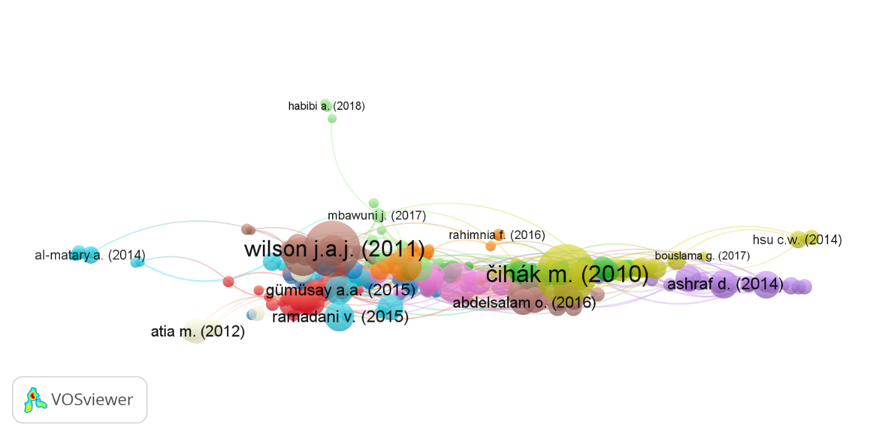

The document "Mirhedayati A.-S. (2021)" has the most citations, 11. However, "Gümüşay A.A. (2020)" has the greatest total link strength 71. This collection has several uncited papers, indicating a lack of references. Despite being rarely cited, certain documents have high overall link strength, showing strong citation linkages. However, some documents contain many citations but low total link strength, indicating frequent citations without solid interconnections.

**Co-Citation**

The next step is to visualize the journals that are interrelated with Islamic management. We can see it in Figure 7. The author set the minimum citation limit to 45, got 152 articles, and obtained five clusters. The five clusters are generally related to Islamic management, so these links can still be explored in more detail. The journals above also have a substantial relationship: each quote from a different Islamic management topic is quoted from journals visualized using VOSviewer. The result is that every journal with a relationship is a journal from the same cluster, is relevant to each other, and has a close relationship with Islamic Management.

**Figure 7** *Co-citation*

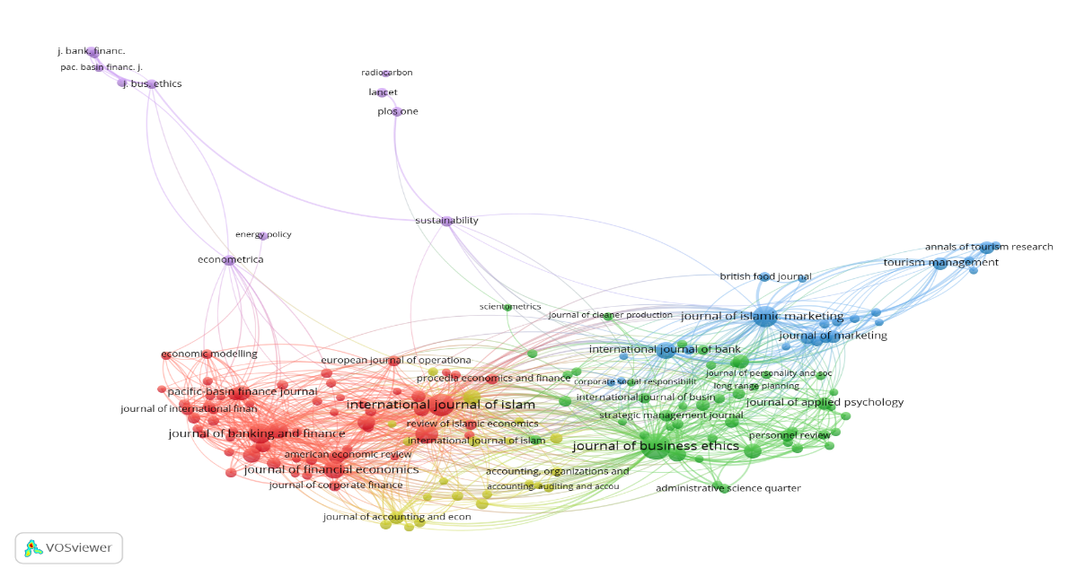

**Co-Authorship**

The author uses the fractional counting method with the VOSviewer software to explore writers related to their work. The goal is to find out how many authors are intensively interrelated on this topic and outline visualizations from VOSviewer. The author also explores the writer's country of origin, as seen in Figure 8.

**Figure 8** *Co-authorship by author*

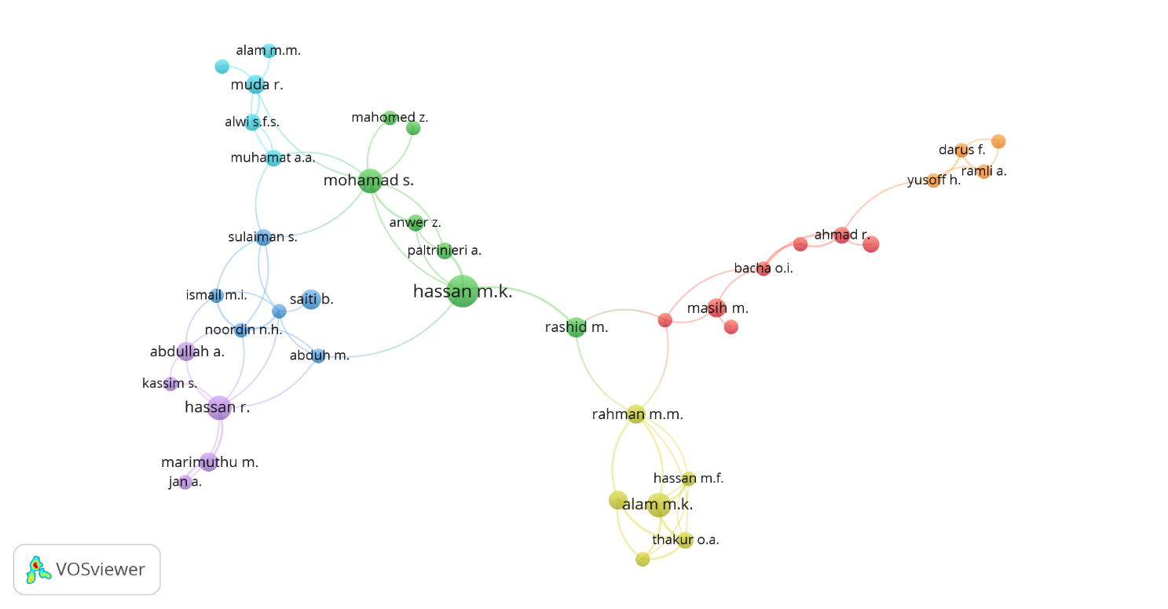

Additionally, this text elucidates the interconnectedness of the authors' respective national backgrounds. The subsequent component depicted in the diagram is the Series, which elucidates the presence of a sequential arrangement predicated on diverse clusters, whereby each hue inside the cluster holds a distinct significance. The initial cluster depicted in the Figure is denoted by the color red. It encompasses the names of writers such as Masih M, Ahmad R, and Mirakhor A. Within this cluster, three papers are generated. The second cluster exhibits a green hue, indicating a relationship with the first cluster. This cluster encompasses 15 papers that share interrelatedness. The authors associated with the second cluster, such as Mohamed S, Hassan, and Anwer Z, are denoted by a dark green reference.

Moreover, inside the third cluster, which yields three documents, the authors identified in this cluster are Abduh M, Ismail M, and Sulaiman S. The third cluster is visually represented by dark blue. Cluster 4 is represented by the color dark yellow and comprises nine papers authored by Rahman M.M, Alam M., and K., as well as Hasan M.F. Cluster 5, shown by the color purple, also consists of nine documents authored by Hasan R., Abdullah A, and Kassim S. Cluster 6 consists of five documents, which are characterized by a light blue color and authored by Alwi S., Abdul Rahman R., and Alam M.M. On the other hand, cluster 7 is represented by an orange color and includes the authors Darus F., Yusoff, Ramli, and Ismail.

**Cartography Analysis**

The author uses the cartography analysis method, which can also complete clusters, identify themes in depth, and find the keywords most often used in publications about Islamic Management, like the one in Figure 9. The ten have been grouped in clusters, and the colors in each cluster have been denoted. For example, the author says, "The minimum number of citations is set to 28 and gets 32 items divided into three clusters, namely Cluster 1 is red, cluster 2 is green, and cluster 3 is blue.

**Figure 9** *Co-Occurrence*

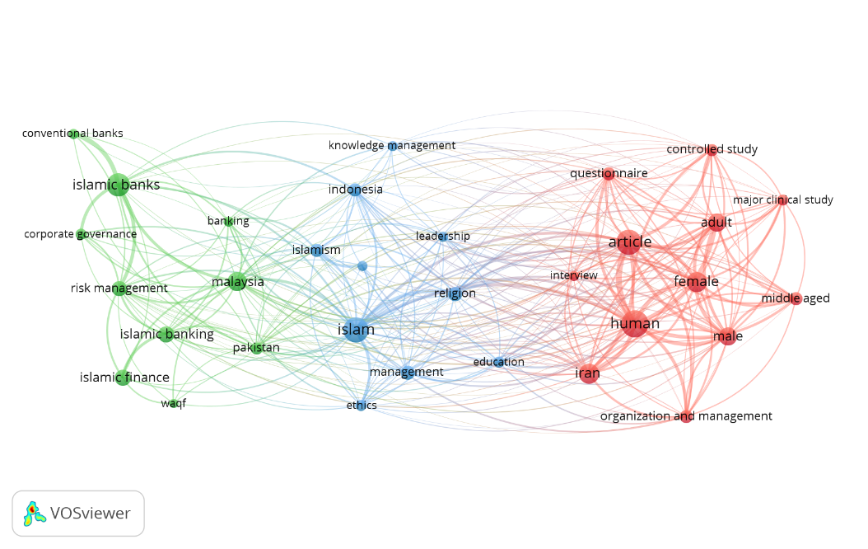

The author also attaches keyword data and the number of occurrences in Table 6. Link strength is a measure of strength between one item and another. They obtained three frequently used keywords: Human, Islamic banks, and Islam.

**Table 6** *Keywords and the Number of Occurrences along with the Link Strength*

|  |  |  |  |
| --- | --- | --- | --- |
| No | Keyword | Occurrences | Total link strength |
| Cluster 1 | Organization and Management |  |  |
| 1 | Adult | 95 | 95 |
| 2 | Article | 83 | 77 |
| 3 | Controlled study | 46 | 46 |
| 4 | Female | 120 | 120 |
| 5 | Human | 213 | 212 |
| 6 | Interview | 29 | 28 |
| 7 | Iran | 60 | 83 |
| 8 | Major clinical study | 34 | 34 |
| 9 | Male | 100 | 100 |
| 10 | Middle-aged | 50 | 49 |
| 11 | Organization and Management | 52 | 52 |
| 12 | Questionnaire | 50 | 50 |
| Cluster 2 | Risk Management |  |  |
| 1 | Banking | 31 | 22 |
| 2 | Conventional bank | 29 | 28 |
| 3 | Corporate Governance | 36 | 25 |
| 4 | Islamic banking | 72 | 32 |
| 5 | Islamic banks | 155 | 82 |
| 6 | Islamic finance | 74 | 24 |
| 7 | Malaysia | 106 | 63 |
| 8 | Pakistan | 43 | 35 |
| 9 | Risk Management | 71 | 49 |
| 10 | Waqf | 28 | 9 |
| Cluster 3 | Ethics Management |  |  |
| 1 | Conflict management | 30 | 17 |
| 2 | Education | 36 | 29 |
| 3 | Ethics | 34 | 29 |
| 4 | Indonesia | 53 | 33 |
| 5 | Islam | 177 | 123 |
| 6 | Islamism | 48 | 32 |
| 7 | Knowledge management | 31 | 10 |
| 8 | Leadership | 29 | 19 |
| 9 | Management | 60 | 33 |
| 10 | Region | 60 | 52 |

Cartography analysis is a method that can describe and explain that keywords are most often used in journals related to Islamic Management. Proven by this method produced in the first cluster, the existing keywords mainly discuss Islamic management and the controller or regulator of a person in organizing management, which has become a theme or sub-theme in a related journal. The second cluster of Islamic management is to prepare for risk in Islamic Finance. Finally, the last cluster explains that Islamic management, in the form of knowledge learned, becomes an ethics in conflict management.

The author successfully studied three clusters from 451 Islamic Management. The direction of future research follows the subsequent discussion.

**CONTENT ANALYSIS AND RESEARCH AGENDA**

**Research Streams**

Research stream 1: Organization and management as a tool. In the first research, there was a focus on Organization and management as a learning tool. In the concept of Organization and management as a learning tool, the author focuses on ethical management, creating relationships between employees and customers, and creating an environment full of ethics (Faisal, 2021). Another author mentions that Organization and management are tools to identify various activities. For example, in risk management, activities attached to a system are also used to strengthen a system that runs so that it has little risk. These risks also include moral risks, so Organization and management are critical for learning to minimize a moral risk. Organization and management if someone is going to do something, namely tending to think about the impact that will occur next and more consider something willing to be taken(Kvasnytska et al., 2023). Organization and management are often used in overcoming socio-economic difficulties, among which in the processing of funds in Islam can also be a lesson by us managing the needs of the funds we spend based on the priority of needs so that we can process the funds in a structure (Hafriza et al., 2018). Likewise, it must be done consistently to run and avoid things affecting organization and management consistency (Kvasnytska et al., 2023).

Research stream 2: Risk management in Islamic finance. Risk management in Islamic finance is carried out to focus on mechanisms in governance that explain the relationship between effectiveness in management and provide an overview and prudence in providing inequality because it can influence strategic decisions (Jallali & Zoghlami, 2022). Critical challenges are also always taken in making a decision; the author suggests that decision-making must consider all aspects and all fields because this decision can affect a system that has been formed, then also assess the conditions for evaluating uncertain risks, analyzing and prioritizing the needs that are needed (Sohrabi Tabar et al., 2022). The author also said that it considers low potential as a critical component in any decision-making based on the Qur'an to strengthen stability in policy decisions (ArjiHarahap, 2000). The concept of risk management in Islamic finance is also put forward because of the consideration of risk as a macroeconomic driver; if economic policies and financial uncertainty are at odds with each other or taken without consideration of risk, make an impact on equities, tight credit conditions, there is a slowdown in economic activity, to minimize this possibility is in a way as in this author by strengthening macro factors against risk credits that are causing a threat to stability in finances (Yfanti et al., 2023).

Research stream 3: Implication ethics management of Islam for conflict management. The problem focuses on moral management issues that should get more attention for various reasons that cannot be underestimated. The author reveals the rise of moral scandals in various social and economic aspects; there are also often unhealthy practices such as untransparent frameworks, embezzlement, bribery, and abuse(Faisal, 2021). In facing conflict management, some steps can affect the performance of an organization itself, as the author conveys that decision-making is very ineffective because of the factors of vacillation and doubt when facing or when conflict management occurs; with these circumstances, the author emphasizes that the most positive behavioral milestones and habits as taught by every Muslim to always pray before doing something decision making and knowing what consumers want and making conflict management occur (Wilson et al., 2013). The author conveys that Islam also audits ways to manage conflict by approaching employees and individuals to remain calm in decision-making (Munadi & Aisyiah, 2022). The existence of legal control in an organizational system is to have higher standards and work ethics with the aim of creating relationships and a warm environment. These things are essential because management ethics is the attitude used to determine a decision when conflict occurs (Faisal, 2021)

**Research Agenda**

The initial cluster of research in Organization and Management focuses on examining the interplay between these elements within the Islamic setting while also drawing comparisons with perspectives outside the Muslim faith. Future study potential can be found in exploring management from different philosophical perspectives and expanding data collection methods beyond questionnaires, interviews, and observations. The second cluster focuses on comprehensive research in Islamic banking, particularly on risk management, waqf, governance, territorial concerns, and human and financial resource management. Nevertheless, the current body of research on corporate social responsibility (CSR) in the banking sector needs to be improved, particularly regarding its coverage across various areas. This underscores the need to explore and examine this topic further in future studies. The third cluster focuses on ethics management in several domains, particularly ethical issues in conduct, particularly within the education sector. Moreover, the convergence of leadership and knowledge management is pivotal in facilitating well-informed decision-making. Islamic principles effectively mitigate and resolve problems within Islamic shelters.

**CONCLUSION**

In the field of Islamic management research, the year 2020 witnessed a notable surge in the number of publications. Among the various institutions contributing to this output, the International Islamic University Malaysia emerged as the most prolific affiliate, producing 129 scholarly documents. Furthermore, Malaysia demonstrated its significance in Islamic management publications, accounting for the most relevant documents with a total 621. One particular publication that garnered substantial attention within this domain is "Islamic Banks and Financial Stability: An Empirical Analysis," authored by Čihák M and published in 2010. This document stands out due to its remarkable local citation count of 25 and global citation count of 392, thus attesting to its influential impact within the academic community. The topic of Islamic management has a close relationship with the quotations of the journal Business Ethics, which firmly explains that Islamic management is closely related to these journals. From the data collected, the Journal of Islamic Accounting and Business Research has the highest impact, alongside the Journal of Islamic Marketing, which is also very relevant to Islamic Management. The data also speaks of a prolific author, "Hassan Mk" who has relevant writing work in Islamic Management. This research also brings up the latest themes of Islamic management obtained from the scatological analysis that gives rise to or displays frequently used keywords. The themes are 1) Organization and management as a learning tool, 2) Risk management in Islamic finance, and 3) Implication ethics management of Islam for conflict management. With the development of the topic, there are also these themes to enrich the topic's relevance and expand the subsequent research. This research needs to be more comprehensive because it only uses Scopus as a database. The next researcher can use other databases for relevant importance and enrich the following research. This research explains that in the future, Islamic management will focus on tools that function for learning at all ages so that their lives are maintained with the existence of Islamic Management, the most important of which is finance. In cluster two, it is explained that risk management in Islamic finance is carried out to focus on mechanisms in governance that explain the relationship between effectiveness in management to minimize risks that will occur. The research in the third cluster implies applying ethics in financial management to create a warm environment. An attitude known as management ethics guides decisions during conflict.

**Funding Acknowledgment**

We express our deepest gratitude to the Faculty of Islamic Studies and the Research and Innovation Institute (LRI) at Universitas Muhammadiyah Surakarta for their invaluable support and guidance.

# REFERENCES

Allah Pitchay, A. (2022). Factors influence intention of management of Shariah-compliant companies to participate in Islamic voluntary charity. *International Journal of Islamic and Middle Eastern Finance and Management*. https://doi.org/10.1108/IMEFM-11-2019-0466

Apriantoro, M S, Herviana, J., & Yayuli, Y. (2023). Sharia Financial Literacy: Research Trends and Directions for Future Inquiry. *Journal of Islamic Economic Laws*, *6*(2), 19–40.

Apriantoro, Muhamad Subhi, & Diniyah, D. N. (2024). Riding the Tides of Change: A Bibliometric Expedition on Technology-Enabled Circular Economy. *Multidisciplinary Reviews*, *Accepted Articles*.

Apriantoro, Muhamad Subhi, Faradilla, S., Ashfahany, A. El, Maruf, A., & Aziza, N. A. (2024). Quantifying Intellectual Terrain: Islamic Jurisprudence, Ethical Discourse, and Scholarly Impact. *Suhuf*, *36*(1), 78–85. https://doi.org/10.23917/suhuf.v36i1.4367

Apriantoro, Muhamad Subhi, Kaloka, R. D., El Ashfahany, A., & Hudaifah, H. (2023). Exploring Muhammadiyah's Research Landscape: A Bibliometric Analysis and Emerging Trends. *Cakrawala: Jurnal Studi Islam*, *18*(2).

Apriantoro, Muhamad Subhi, Muthoifin, M., & Athief, F. H. N. (2023). Advancing social impact through Islamic social finance: A comprehensive bibliometric analysis. *International Journal of Advanced and Applied Sciences*, *10*(11), 81–89. https://doi.org/https://doi.org/10.21833/ijaas.2023.11.011

Apriantoro, Muhamad Subhi, & Wijayanti, N. R. (2022). Bibliometric Analysis of Research Directions In Islamic Bank In The Pandemic Period. *NISBAH: Jurnal Perbanka Syariah*, *8*(2), 127–137.

ArjiHarahap, S. (2000). Implementasi Manajemen Syariah Dalam Fungsi-Fungsi Manajemen. *Journal of Visual Languages & Computing*, *11*(3), 287–301.

Arviah, N. (2020). Manajemen Dalam Islam (Perspektif Al-Qur’an dan Hadits. *Sketsaonline.Com*, *5*, 12.

Bouheraoua, S., & Djafri, F. (2022). Adoption of the COSO methodology for internal Sharīʿah audit. *ISRA International Journal of Islamic Finance*. https://doi.org/10.1108/IJIF-04-2020-0071

Chen, C., & Song, M. (2019). Visualizing a field of research: A methodology of systematic scientometric reviews. *PLOS ONE*, *14*(10), e0223994. https://doi.org/10.1371/journal.pone.0223994

Faisal, S. A. (2021). The moral dimension in Islamic management: A study of the features of management in Islam compared to some global administrations. *Review of International Geographical Education Online*, *11*(4), 19–27. https://doi.org/10.33403/rigeo.800622

Ghani, F. A., & Apriantoro, M. S. (2023). A Study of Waste Transaction Practices and Islamic Jurisprudence at Bank Sampah. *ETHICA: International Journal of Humanities and Social Science Studies*, *1*(1), 20–27.

Hafriza, R. H., M.H, F., & Chuzairi, A. (2018). Manajemen Zakat Sebagai Penyeimbang Perekonomian Umat. *Perada*, *1*(1), 45–58. https://doi.org/10.35961/perada.v1i1.6

Hambali, K. M. K., Paudzi, N. H. M., & Sallam, A. N. S. M. (2022). Islamic Perspective on the Concepts of Interaction Among Multicultural Society. *Afkar*, *23*(2), 249–274. https://doi.org/10.22452/afkar.vol23no2.7

Jallali, S., & Zoghlami, F. (2022). Does risk governance mediate the impact of governance and risk management on banks' performance? Evidence from a selected sample of Islamic banks. *Journal of Financial Regulation and Compliance*, *30*(4), 439–464. https://doi.org/10.1108/JFRC-04-2021-0037

Kazak, H. (2023). Is Islamic financial management getting enough attention? A bibliometric analysis. *Journal of Islamic Accounting and Business Research*. https://doi.org/10.1108/JIABR-02-2023-0068

Kvasnytska, R., Dotsenko, I., Matviychuk, L., & Oliinyk, L. (2023). Organization of Management of Moral Risks of Banking Activity in a Modern Business Environment. *Lecture Notes in Networks and Systems*, *487*, 243–249. https://doi.org/10.1007/978-3-031-08084-5_18

MacRoberts, M. H., & MacRoberts, B. R. (1989). Problems of citation analysis: A critical review. *Journal of the American Society for Information Science*, *40*(5), 342–349. https://doi.org/10.1002/(SICI)1097-4571(198909)40:5<342::AID-ASI7>3.0.CO;2-U

Martínez-Climent, C., Zorio-Grima, A., & Ribeiro-Soriano, D. (2018). Financial return crowdfunding: literature review and bibliometric analysis. *International Entrepreneurship and Management Journal*, *14*(3), 527–553. https://doi.org/10.1007/s11365-018-0511-x

Md Husin, M., Aziz, S., & Iqbal, M. (2023). A bibliometric and visualization analysis of Islamic fund management research. *Journal of Islamic Marketing*. https://doi.org/10.1108/JIMA-04-2023-0116

Munadi, M., & Aisyiah, H. N. (2022). Internal Audit Management in Islamic Higher Education: An Effort to Minimize the Potential of Audit Findings. *Journal of Higher Education Theory and Practice*, *22*(15), 106–119. https://doi.org/10.33423/jhetp.v22i15.5564

Naz, S. A., & Gulzar, S. (2022). IMPACT of ISLAMIC FINANCE on ECONOMIC GROWTH: AN EMPIRICAL ANALYSIS of MUSLIM COUNTRIES. *Singapore Economic Review*, *67*(1), 245–265. https://doi.org/10.1142/S0217590819420062

Nielsen, M. W., & Andersen, J. P. (2021). Global citation inequality is on the rise. *Proceedings of the National Academy of Sciences*, *118*(7). https://doi.org/10.1073/pnas.2012208118

Saiti, B., Ardo, A. A., & Yumusak, I. G. (2022). Why non-Muslims subscribe to Islamic banking? *Qualitative Research in Financial Markets*, *14*(2), 247–269. https://doi.org/10.1108/QRFM-01-2018-0005

Selvarajah, C., Meyer, D., & Bose, T. K. (2018). Organisational Leadership in Bangladesh: An Investigation of Managerial Response to A Change Environment. *Contemporary Management Research*, *14*(1). https://doi.org/10.7903/cmr.18341

Shahab, M. H., Ghazali, E. M., & Mohtar, M. (2022). A Systematic Literature Review and Future Research Agenda for the Gratification Discrepancies Approach. *Contemporary Management Research*, *18*(1), 1–33. https://doi.org/10.7903/cmr.21583

Sofyan, A. S., Abror, A., Putra, T. W., Muslihati, M., Sofyan, S., Sirajuddin, S., Katman, M. N., & Darussalam, A. Z. (2022). Crisis and disaster management for halal tourism: a systematic review. *Tourism Review*, *77*(1), 129–145. https://doi.org/10.1108/TR-08-2020-0390

Sohrabi Tabar, V., Ghassemzadeh, S., & Tohidi, S. (2022). Risk-based day-ahead planning of a renewable multi-carrier system integrated with multi-level electric vehicle charging station, cryptocurrency mining farm and flexible loads. *Journal of Cleaner Production*, *380*. https://doi.org/10.1016/j.jclepro.2022.134898

Wilson, J. A. J., Belk, R. W., Bamossy, G. J., Sandikci, Ö., Kartajaya, H., Sobh, R., Liu, J., & Scott, L. (2013). Crescent marketing, Muslim geographies and brand Islam: Reflections from the JIMA Senior Advisory Board. *Journal of Islamic Marketing*, *4*(1), 22–50. https://doi.org/10.1108/17590831311306336

Yadav, S., Chhabra, A., & Mahesh, G. (2022). Mapping, clustering, and analysis of research in psychiatric genomics. *Psychiatric Genetics*, *32*(6), 221–237. https://doi.org/10.1097/ypg.0000000000000325

Yfanti, S., Karanasos, M., Zopounidis, C., & Christopoulos, A. (2023). Corporate credit risk counter-cyclical interdependence: A systematic analysis of cross-border and cross-sector correlation dynamics. *European Journal of Operational Research*, *304*(2), 813–831. https://doi.org/10.1016/j.ejor.2022.04.017

Zain, C. R. C. M., & Zakaria, Z. (2022). Integration of Islamic Management Principles and Values according to the Qur'an and Hadith in Fostering Halal Governance in Malaysia. *AlBayan*, *20*(2), 157–181. https://doi.org/10.1163/22321969-12340112

**Dr. Muhamad Subhi Apriantoro (Corresponding author)** is a senior researcher at the Department of Sharia Economic Law, Faculty of Islamic Studies, Universitas Muhammadiyah Surakarta, Indonesia. Specializing in Islamic philosophy, economics, literature, and comparative jurisprudence, he conducts bibliometric research to identify trends and future directions in Islamic law, finance, and jurisprudence.

**Ilham Widhi Susanto** is a master's student specializing in Sharia Economics at Universitas Muhammadiyah Surakarta, Indonesia. He is a research assistant, contributing to various projects in Islamic finance and jurisprudence. His academic interests focus on applying Sharia principles in contemporary economic practices.